$20,000.00
MILLER – GERMAN
AKASKA GOETZ ADDN LOT 17 BLOCK 2
1975 12’ X 57’ ATLANTIC
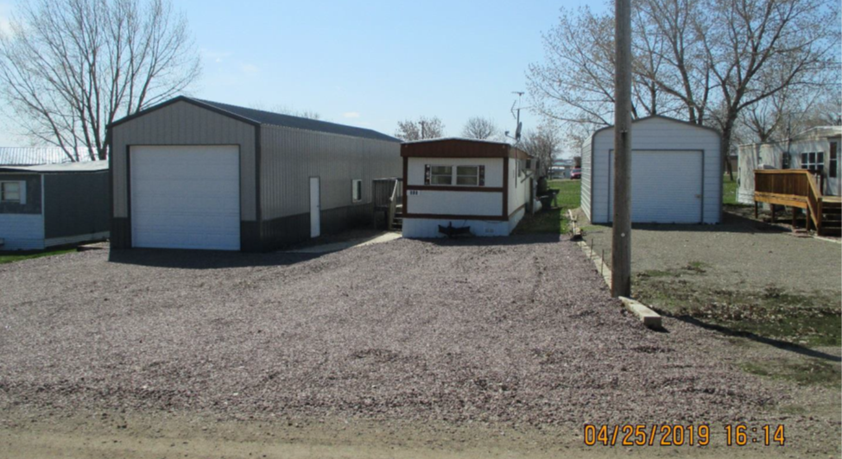
RECORD # 7537

LOT SIZE 50’ X 100’ LIVING AREA 684 SQ FT
MANUFACTURED HOME METAL SIDING
AVERAGE QUALITY & CONDITION WINDOW AIR
1975 ATLANTIC
TITLE: Y44554
SERIAL #4757021304 GARAGE BUILT AFTER SALE
SOLD ON 11/03/19 FOR $20,000
ASSESSED IN 2019 AT $11,810 RECORD #7537
ASSESSED IN 2014 AT $11,320

