$5,000.00
HUMMEL-CHRISTMAN
207 1ST AVE WEST, MOBRIDGE
MOBRIDGE ORIGINAL LOT 5 BLOCK 5
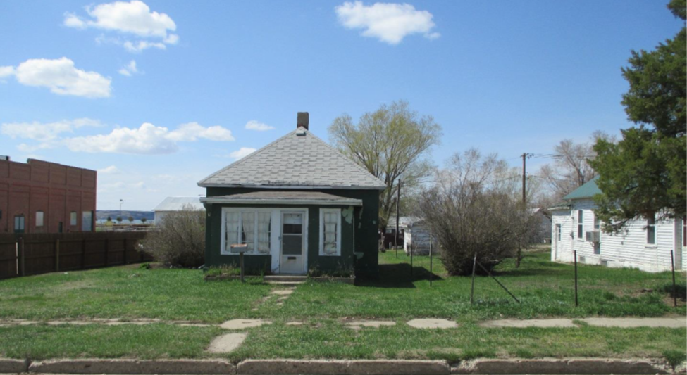
RECORD #6265

LOT SIZE 50’ X 140’ TOTAL LIVING 630 SQ FT
SINGLE FAMILY-ONE STORY ONE BEDROOM ONE BATH
CONDITION BADLY WORN DETACHED GARAGE 240 SQ FT
BUILT IN 1910 KNEE WALL PORCH
2015; ROOF FAIR, STUCCO BASEMENT 462 SQ FT
FUEL OIL, SHED STUCCO/TIN ROOF
SOLD ON 10/05/18 FOR $5,000
ASSESSED IN 2019 AT $9,750
ASSESSED IN 2014 AT $9,590 RECORD #6265

