$120,000.00
STEEN-HETTICK
809 8TH AVE WEST
MOBRIDGE NWTS CO’S 3RD ADDN LOT 5 & 25’ OF LOT 4 BLOCK 32
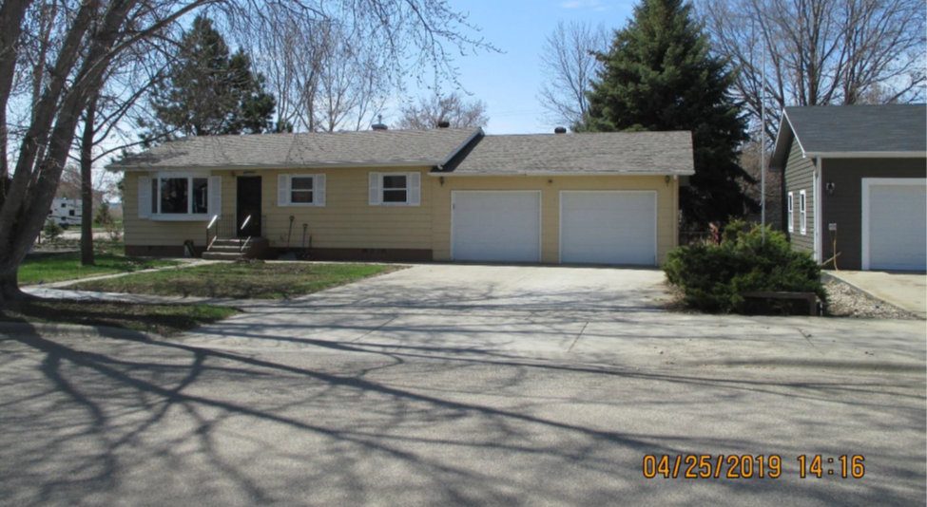
RECORD #6153

LOT SIZE 75’ X 120’ GROUND FLOOR 886 SQ FT
SINGLE FAMILY-ONE STORY 2 BEDROOMS ABOVE 1 BELOW
AVERAGE QUALITY & CONDITION 1 FULL BATH 2 HALF BATHS
BUILT IN 1968 BASEMENT 886 SQ FT
CENTRAL AIR-NATURAL GAS BASEMENT 443 SQ FT FINISHED
SOLD ON 11/12/18 FOR $120,000 ATTACHED DOUBLE GARAGE
SOLD IN 2016 FOR $110,000 DETACHED GARAGE 576 SQ FT
SOLD IN 2015 FOR $100,000 20’ X 34’ THREE SEASONS PORCH
ASSESSED IN 2019 AT $109,500 UTILITY SHED 10’ X 12’
ASSESSED IN 2012 $72,080 RECORD #6153

