$25,000.00
VOLLER – SCHILLINGSTAD
704 2ND AVE EAST, MOBRIDGE
MOBRIDGE MILES ADDN LOT 4 BLOCK 1
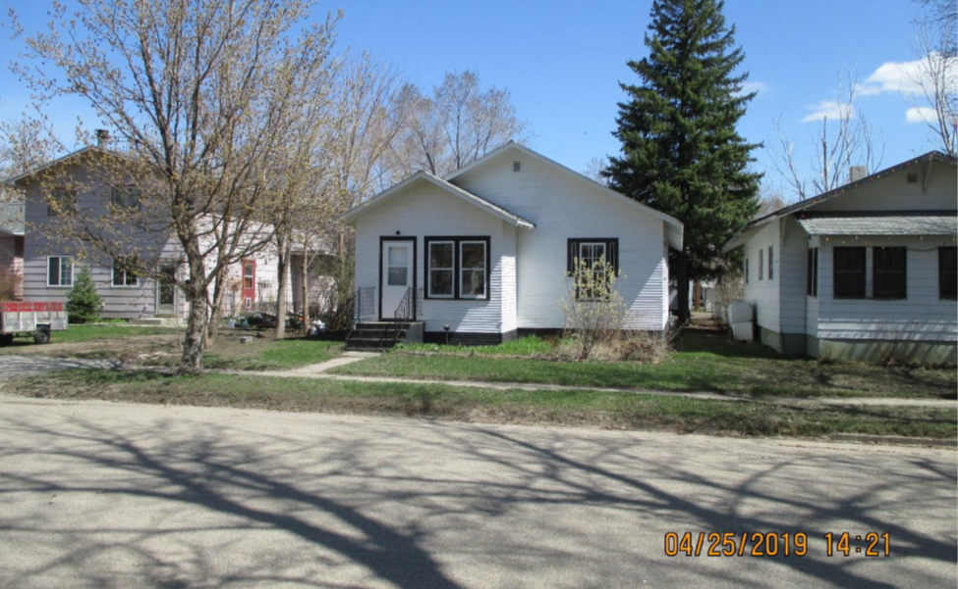
RECORD #5734

LOT SIZE 40’ X 140’ GROUND FLOOR 936 SQ FT
SINGLE FAMILY – ONE STORY 2 BEDROOMS 1 BATH
AVERAGE QUALITY & CONDITION BASEMENT 936 SQ FT
BUILT IN 1910 DETACHED GARAGE 240 SQ FT
NATURAL GAS, WINDOW AIR SOLID WALL PORCH 78 SQ FT
SOLD ON 10/16/2018 FOR $25,000 WOOD DECK 100 SQ FT
ASSESSED IN 2019 AT $24,430
ASSESSED IN 2013 AT $21,245 RECORD #5734

