$53,000.00
SHILLINGSTAD-WALTHER
1212 PARK LANE, MOBRIDGE
MOBRIDGE BEL AIRE 1ST ADDN LOT 28 BLOCK 1
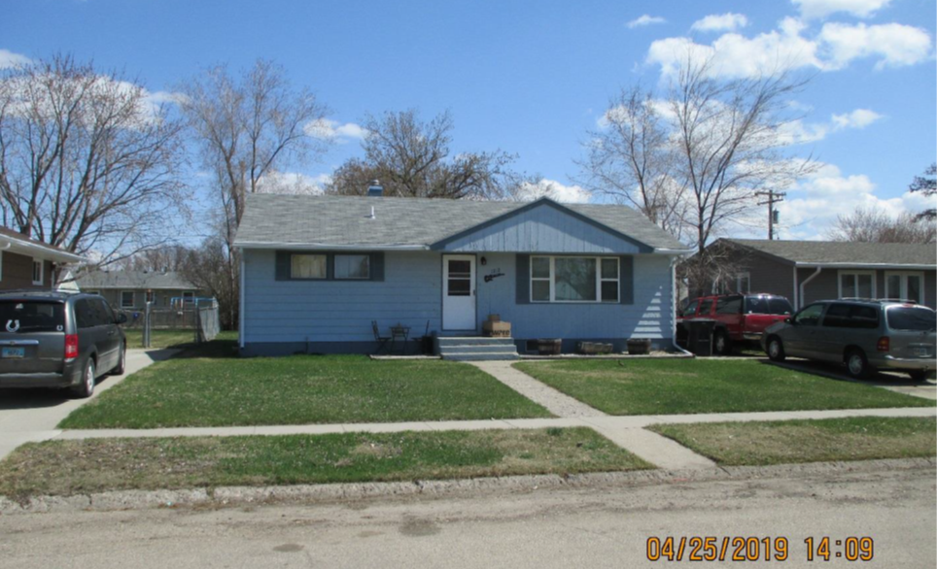
RECORD #4707

LOT SIZE 60’ X 123.6’ GROUND FLOOR 960 SQ FT
SINGLE FAMILY ONE STORY 3 BEDROOMS ABOVE 1 BELOW
AVERAGE QUALITY & CONDITION 1 ¾ BATHS
BUILT IN 1960 BASEMENT 960 SQ FT
2014; WOOD SIDING FAIR, POURED CONCRETE 860 SQ FT FINISHED REC.
SUNKEN WINDOWS, WINDOWS FAIR
2000; BASEMENT 90% FINISHED
SOLD ON 4/15/19 FOR $53,600
ASSESSED IN 2019 $43,350
SOLD IN 2014 FOR $40,000 (PD)
ASSESSES IN 2015 AT $49,450 RECORD #4707

