$30,000.00
BRANTLEY – DIAZ
4604 2ND AVE. SELBY
SELBY ORIGINAL LOT 3 & N 10’ EX WEST 10’ OF LOT 4 BLOCK 2
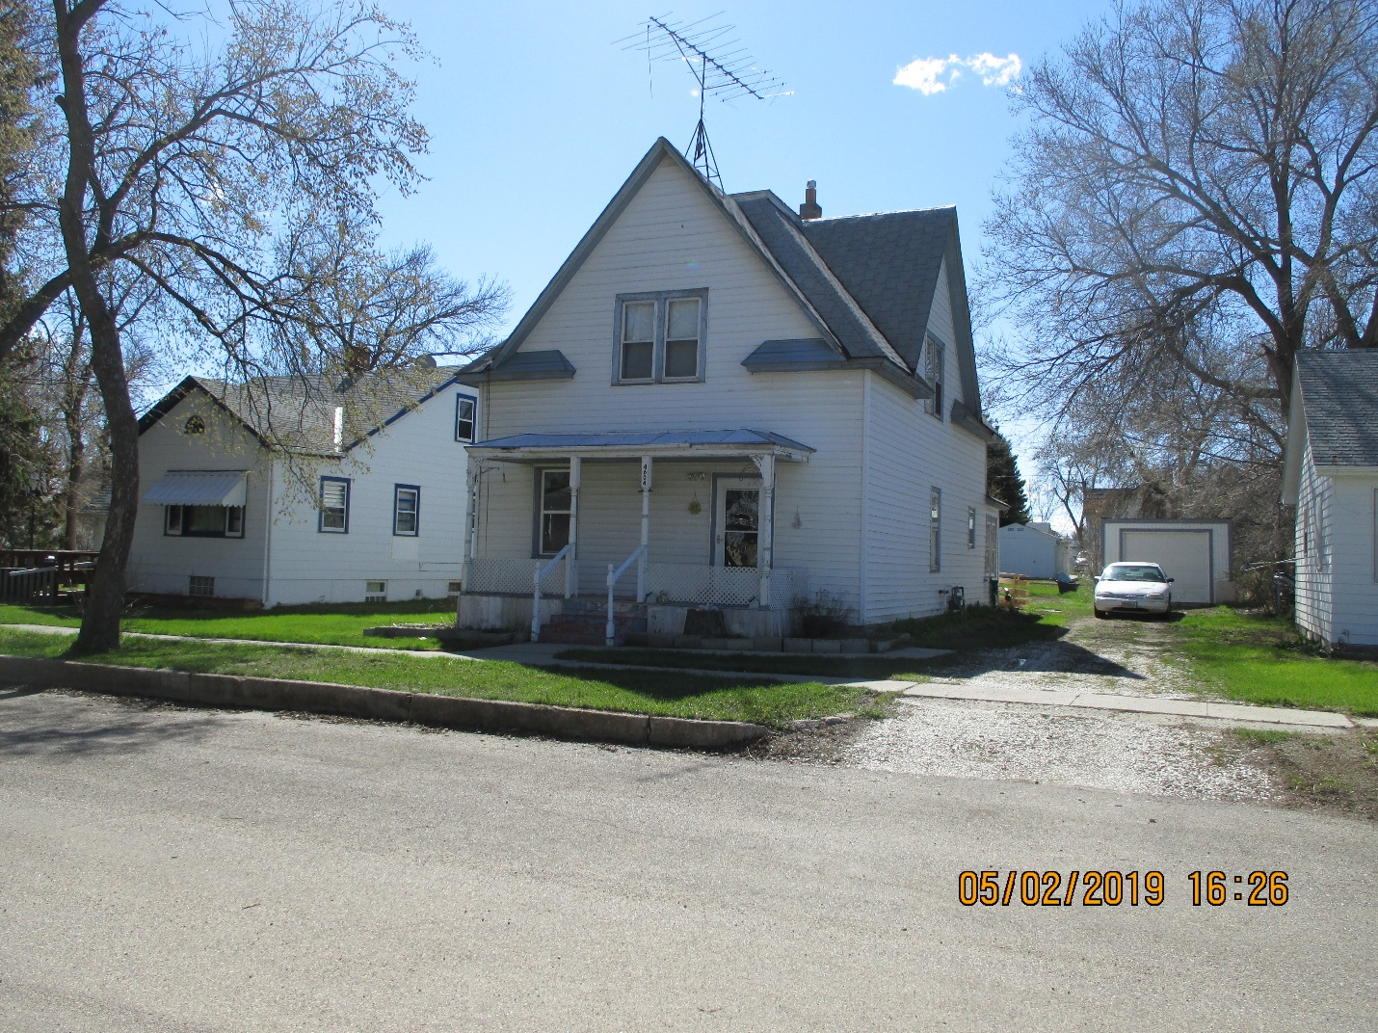
RECORD #4408

LOT SIZE 50’ X 140’ GROUND FLOOR 944 SQ FT
& 10’ X 130’ TOTAL AREA 1376 SQ FT
SINGLE FAMILY- 1 ½ STORY 4 BEDROOMS 2 ½ BATHS
AVERAGE QUALITY & CONDITION ROOFED PORCH 108 SQ FT
BUILT IN 1924 KNEE WALL PORCH 112 SQ FT
2015; VINYL SIDING, WINDOW AIR OPEN SLAB PORCH 133 SQ FT
NATURAL GAS, 2010; NEW WALLS DETACHED GARAGE 240 SQ FT
WINDOWS, DOORS
SOLD ON 11/26/18 FOR $30,000; IN 2009 FOR $15,000
ASSESSED IN 2019 AT $29,390; 2015 AT $20,680 RECORD #4408

