$10,000.00
SCHUR – LEMBURG
LOWRY ORIGINAL PLAT LOTS 8, 9, 10 BLOCK 6
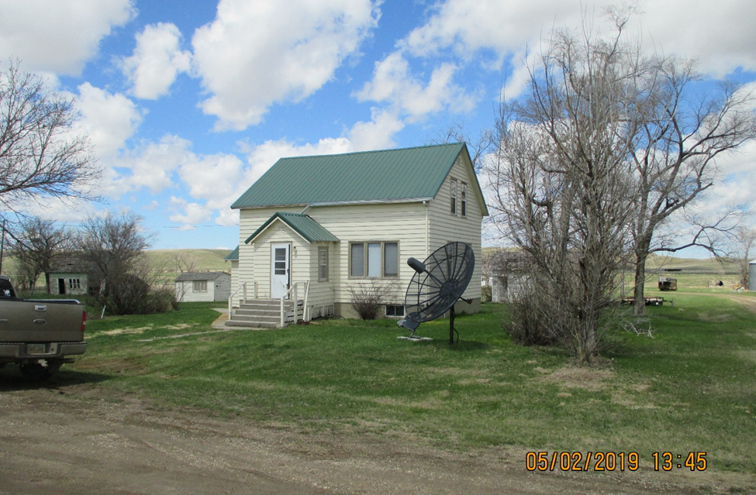
RECORD # 4219

LOT SIZE 172.8’ X 132’ GROUND FLOOR 616 SQ FT
SINGLE FAMILY – 1 ½ STORY SECOND FLOOR 308 SQ FT
WORN CONDITION & QUALITY 924 TOTAL SQ FT LIVING
BUILT IN EARLY 1900’S BASEMENT 616 SQ FT
1999 NEW FURNACE BASEMENT HALF FINISHED
SOLD ON 8/31/2018 FOR $10,000 SOME WATER PROBLEMS IN BSMT
ASSESSED IN 2019 AT $8,545 3 BEDROOMS 1 BATH
SOLD IN 2006 FOR $2,5OO DETACHED GARAGE 308 SQ FT
ASSESSED IN 2012 AT $8,535

RECORD #4219

