$430,000.00
KAUP – RANDALL
MAIN ST. AKASKA
AKASKA ORIGINAL LOTS 1, 2, & 3 BLOCK 16
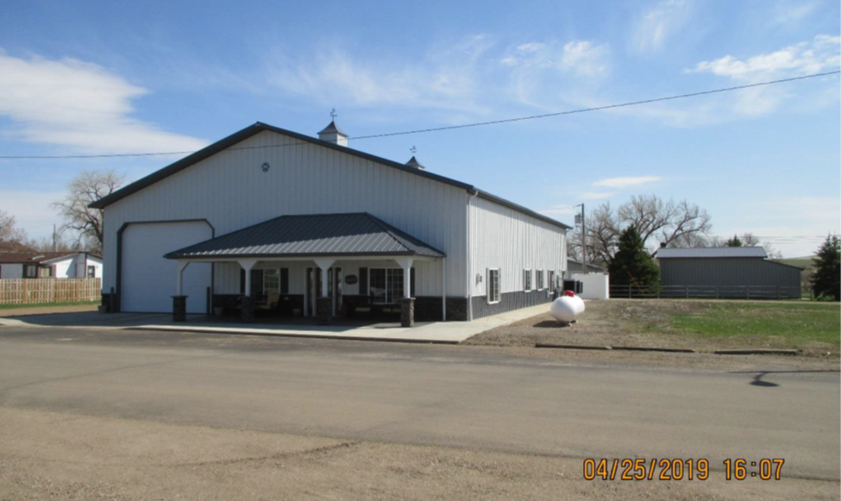
RECORD #3890

LOT SIZE 48’ X 125’ RECORD #3890
METAL FRAME BUILDING
110’ X 60’ BUILDING
BUILT IN 2015
HALF GARAGE STORAGE
HALF 2 STORY LIVING
FRONT AND BACK ENTRANCE GARAGE
FULL KITCHEN WITH WALKOUT TO PATIO
CENTRAL AIR
ROOFED OPEN PATIO 300 SQ FT
SOLD ON 12/06/2018 FOR $430,000
ASSESSED IN 2019 AT $430,000; IN 2015 AT $605,920

