$167,000.00
BIETELSPACHER – MCGUIRE
14741 312TH AVE, NE4 31-121-75
TRACT 1 BEITELSPACHER ADDN IN NE4 31-121-75
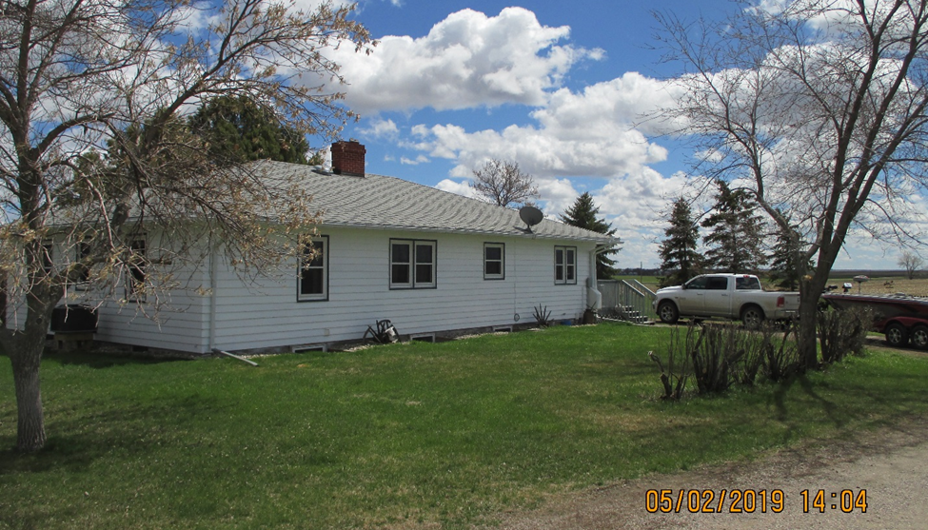
RECORD #325

19.91 ACRES GROUND FLOOR 1600 SQ FT
ONE STORY – SINGLE FAMILY BASEMENT 1600 SQ FT
AVERAGE QUALITY & CONDITION ½ BASEMENT FINISHED REC
BUILT IN 1958 + - 2 BEDROOMS ABOVE 1 BELOW
3 EGRESS WINDOWS 2 BATHS
SOLD ON 6/14/18 FOR $167,000 DETACHED GARAGE 768 SQ FT
ASSESSED IN 2019 AT $116,800 OTHER BLDGS., SHEDS, BINS, ETC.

RECORD #325

