$129,000.00
MCCLELLAN – BROWN
104 14TH ST. WEST, MOBRIDGE
MOBRIDGE THOMPSON’S OUTLOTS LOT 31D
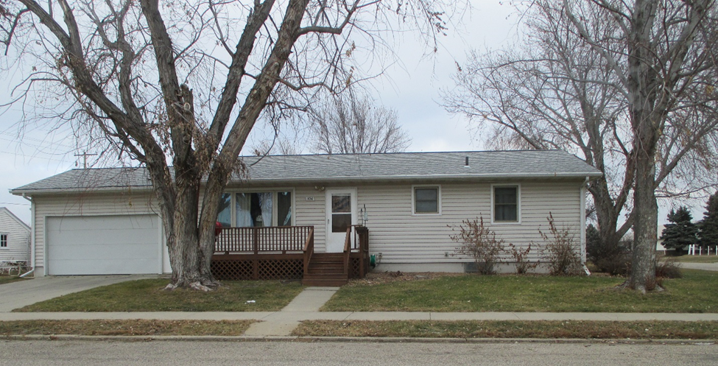
RECORD #6530

LOT SIZE 67’ X 145’ GROUND FLOOR 1092 SQ FT
SINGLE FAMILY – ONE STORY BASEMENT 1092 SQ FT
AVERAGE QUALITY & CONDITION 1000 SQ FT FINISHED REC.
BUILT IN 1965 2 BEDROOMS ABOVE 1 BELOW
2015; ROOF FAIR, 2 EGRESS 1 ¾ BATHS
2001; RESIDE HOUSE, SPRINKLER SYSTEM 22’ X 20’ ATTACHED GARAGE
SOLD ON 6/6/18 FOR $129,000 15’ X 23’ DETACHED GARAGE
ASSESSED IN 2018 AT $120,140 8’ X 16’ WOOD DECK
SOLD IN 2011 FOR $120,000
ASSESSED IN 2014 AT $71,605 RECORD #6530

