$125,000.00
SVIHOVEC-MILLIKEN
1017 1ST AVE WEST, MOBRIDGE
MOBRIDGE MAIN PARK LOT 1 & N 25’ OF LOT 2 BLOCK 23
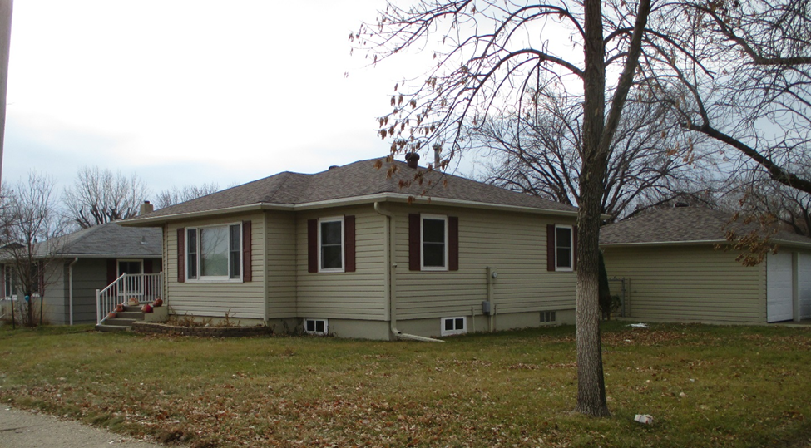
RECORD #5711

LOT SIZE 62.5’ X 142’ GROUND FLOOR 941 SQ FT
ONE STORY-SINGLE FAMILY 2 BEDROOMS ABOVE
AVERAGE QUALITY & CONDITION 1 BEDROOM IN BASEMENT
BUILT IN 1960 2 ½ BATHS
1984; REMODEL KITCHEN BASEMENT 941 SQ FT
2003; SPRINKLER SYSTEM 750 SQ FT FINISHED IN BSMT.
NATURAL GAS - CENTRAL AIR DETACHED GARAGE 890 SQ FT
SOLD ON 6/11/18 FOR $125,000 OPEN SLAB PORCH 300 SQ FT
ASSESSED IN 2018 $108,770
SOLD IN 2001 FOR $62,000
ASSESSED IN 2012 AT $86,510 RECORD #5711

