$60,000.00
KESZLER-VANDERWAL
810 1ST AVE WEST, MOBRIDGE
MOBRIDGE MAIN PARK LOTS 13 & 14 BLOCK 20
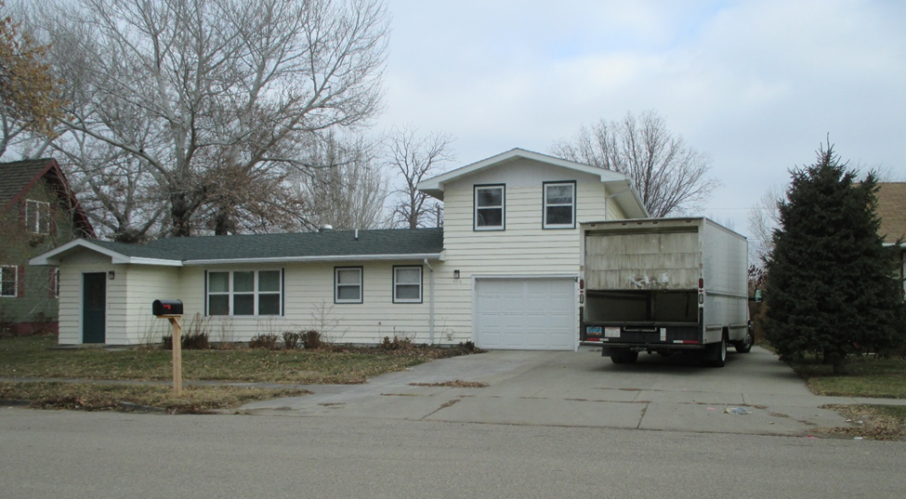
RECORD #5690

LOST SIZE 75’ X 140’ GROUND FLOOR 792 SQ FT
SINGLE FAMILY 2 BEDROOMS ABOVE GARAGE
AVERAGE QUALITY & CONDITION 1 ½ BATHS
BUILT IN 1955 BASEMENT 792 SQ FT
NATURAL GAS – CENTRAL AIR BUILT IN GARAGE 336 SQ FT
BASEMENT HAS FLOODING ISSUES SOLID WALL PORCH 64 SQ FT
SOLD ON 6/8/18 FOR $60,000 KNEE WALL PORCH 196 SQ FT
ASSESSED IN 2018 AT $75,280 OPEN SLAB PORCH 588 SQ FT
ASSESSED IN 2014 AT $50,120 RECORD #5690

