$87,500.00
STOVER – GALAZKA
520 3RD AVE WEST, MOBRIDGE
MOBRIDGE GRAND CROSSING ADDN LOT 17 BLOCK 39
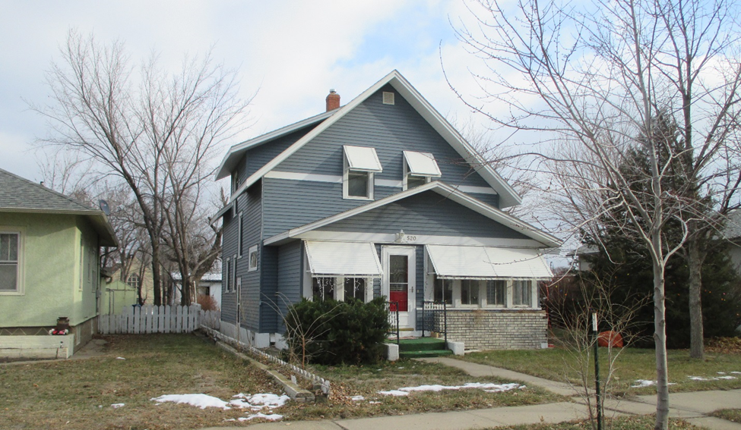
ECORD #5315

LOT SIZE 50’ X 140’ GROUND FLOOR 716 SQ FT
SINGLE FAMILY, 1 ½ STORY TOTAL LIVING 1231 SQ FT
AVERAGE QUALITY & CONDITION 2 BEDROOMS 1 ½ BATHS
BUILT IN 1940 + - BASEMENT 644 SQ FT
2014; VINYL SIDING, NATURAL GAS DETACHED GARAGE 280 SQFT
3 SEASON FRONT PORCH SOLID WALL PORCH 70 SQ FT
2012; STEEL SIDING & NEW SHINGLES KNEE WALL PORCH 189 SQ FT
SOLD ON 9/5/18 FOR $87,500 OPEN SLAB PORCH 84 SQ FT
ASSESSED IN 2018 $24,403
ASSESSED IN 2014 AT $33,725 RECORD #5315

