$15,000.00
DUNWOODY – BISSETT
1200 HELM ST. JAVA
JAVA HELMS 1ST ADDN ALL LOT 1 & N30’ OF LOT 2 BLK 1
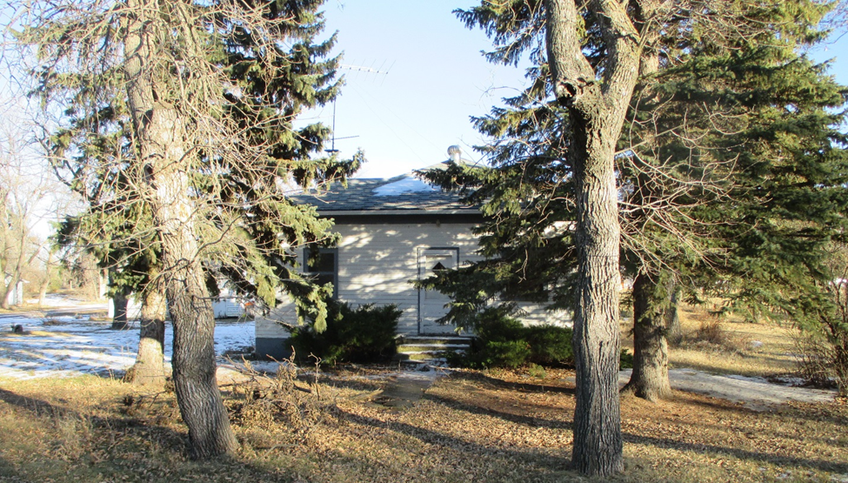
RECORD # 4172

LOT SIZES 100’ X 210 RECORD #4172
& 30’ X 210’
SINGLE FAMILY ONE STORY
POOR CONDITION & QUALITY
BUILT IN 1900
900 SQ FT LIVING AREA
CRAWL SPACE BASEMENT
DETACHED GARAGE 640 SQ FT

