$105,000.00
BENDER-IMBERI
12634 FLYING W ROAD, MOBRIDGE
LOT 58 IN NW4 18-124-79
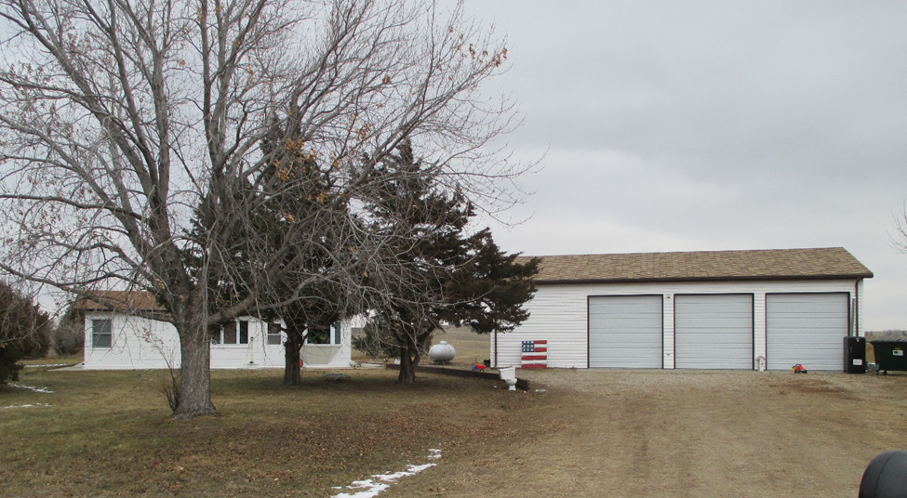
RECORD #3492

LOT SIZE 4.04 ACRES GROUND FLOOR 1080 SQ FT
SINGLE FAMILY ONE STORY 2 BEDROOMS 1 BATH
FAIR CONDITION & QUALITY OPEN SLAB PORCH 216 SQ FT
BUILT IN 1975
CENTRAL AIR
2000; ADD FINISHED BASEMENT
2002; ADD 30’ X 48’ DETACHED GARAGE
SOLD ON 10/19/18 FOR $105,000
ASSESSED IN 2018 AT $68,480
ASSESSED IN 2012 AT $97,765 RECORD #3492

