$135,000.00
PRASEK – GEDITZ
30640 130TH ST, SELBY
LOTS 1 & 2 WEIDEMAN 2ND SUBD SW4 32-124-76
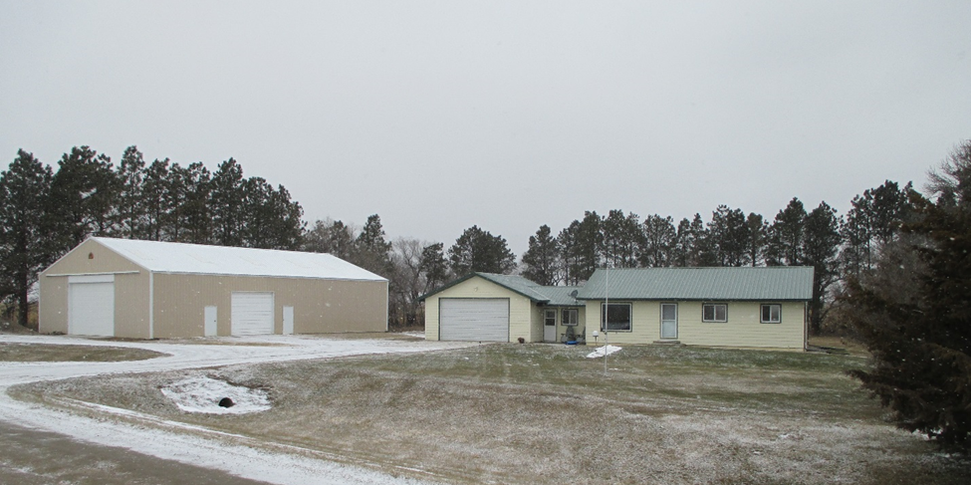
RECORD #2983

LOT SIZE 1.6 ACRES POLE BUILDING 3,504 SQ FT
SINGLE FAMILY – ONE STORY
AVERAGE QUALITY & CONDITION
BUILT IN 1950 + -
LIVING AREA 1092 SQ FT
ATTACHED GARAGE 576 SQ FT
UNFINISHED BASEMENT 1092 SQ FT
6 FIXTURES 1 ROUGH IN
ENCLOSED PORCH KNEE WALLS 144 SQ FT
SOLID WALL PORCH 40 SQ FT
SOLD ON 4/12/18 FOR $135,000
ASSESSED IN 2018 AT $58,955
ASSESSED IN 2012 AT $51,270 RECORD #2983

