$25,000.00
FLEMING – RICKETTS
4707 1ST AVE, SELBY
SELBY OVERHOLSERS ADDN LOT 10 BLOCK 2
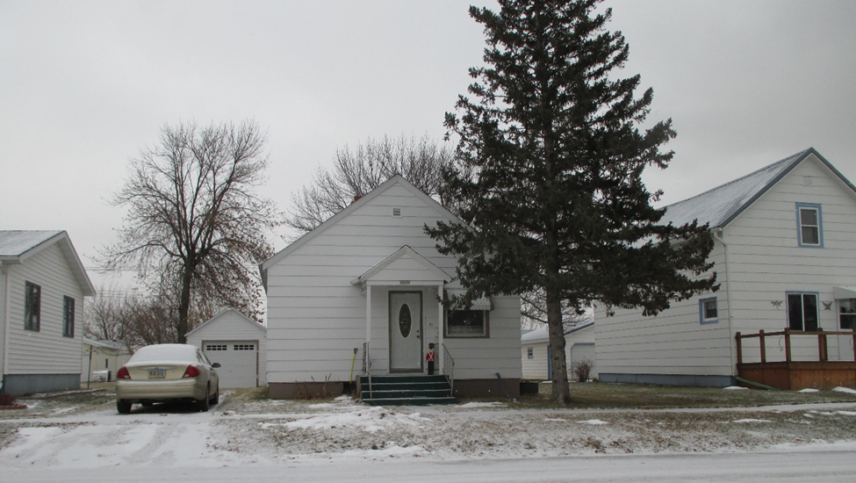
RECORD #4548

LOT SIZE 50’ X 140’ TOTAL LIVING AREA 816 SQ FT
ONE STORY - SINGLE FAMILY 2 BEDROOMS, 1 ½ BATHS
FAIR CONDITION & QUALITY BASEMENT 576 SQ FT
BUILT IN 1910 + - DETACHED GARAGE 240 SQ FT
2015; CENTRAL AIR – NATURAL GAS
WINDOWS POOR, ROOF POOR MOVED IN TO TOWN IN 1958
DETACHED GARAGE SIDING POOR 2008; NEW FLOORING
SOLD ON 9/14/18 FOR $25,000 2008 REPLACE WINDOWS $6,700
ASSESSED IN 2018 AT $23,130
ASSESSED IN 2014 AT $11,090 RECORD #4548

