$425,000.00
BOLDUAN-BANIK
1719 KENNEDY DR. MOBRIDGE
MOBRIDGE SHOR ACRES LOT 103
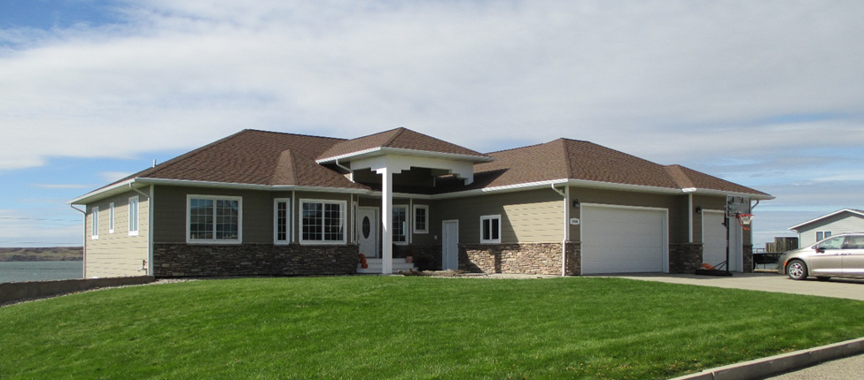
RECORD #6414

LOT SIZE 154’ X 147’ GROUND FLOOR 2261 SQ FT
SINGLE FAMILY ONE STORY 6 BEDROOMS 3 ½ BATHS
AVERAGE QUALITY & CONDITION WALK OUT BASEMENT 2261 SQ FT
BUILT IN 2009 2200 SQ FT FINISHED
ROCK TRIM, WALK OUT BASEMENT ATTACHED GARAGE 1074 SQ FT
LARGE DECK REAR, NATURAL GAS CENTRAL AIR 2476 SQ FT WOODEN DECK
ABOVE GROUND SWIMMING POOL ROOFED PORCH 72 SQ FT
SOLD ON 8/29/18 FOR $425,000
ASSESSED IN 2018 AT $392,720
ASSESSED IN 2012 AT $297,795 RECORD #6414

