$120,000.00
THIES-ANDREWS
609 7TH AVE WEST, MOBRIDGE
MOBRIDGE NWTS CO’S 3RD ADDN S 29 ½ ‘ LOT 3 & ALL LOT 4 BLOCK 39
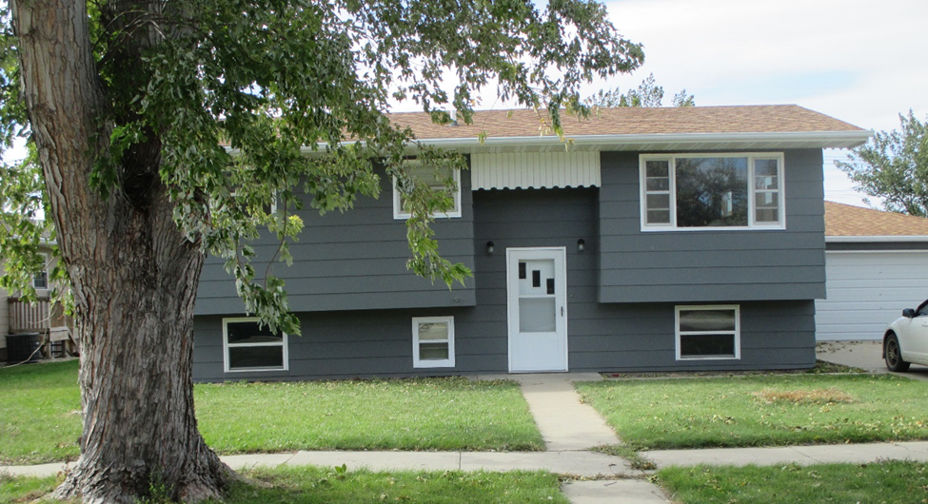
RECORD #6198

LOT SIZE 79 ½ ‘ X 140’ UPPER LIVING SPACE 994 SQ FT
SINGLE FAMILY BI-LEVEL LOWER LEVEL 936 SQ FT
AVERAGE QUALITY & CONDITION 2 BEDROOMS ABOVE 2 BELOW
BUILT IN 1973 2 FULL BATHS, ONE ½ BATH
2014; ROOF FAIR, MASONITE FAIR BELOW LEVEL FINISHED 702 SQ FT
CASEMENT VINYL WINDOWS GOOD ATTACHED GARAGE 1008 SQ FT
NATURAL GAS CENTRAL AIR SOLID WALL PORCH 56 SQ FT
SOLD ON 9/8/18 FOR $120,000 GARAGE IS DRIVE THRU
ASSESSED IN 2018 AT $95,160
SOLD IN 2002 FOR $72,000
ASSESSED IN 2012 AT $85,785 RECORD #6198

