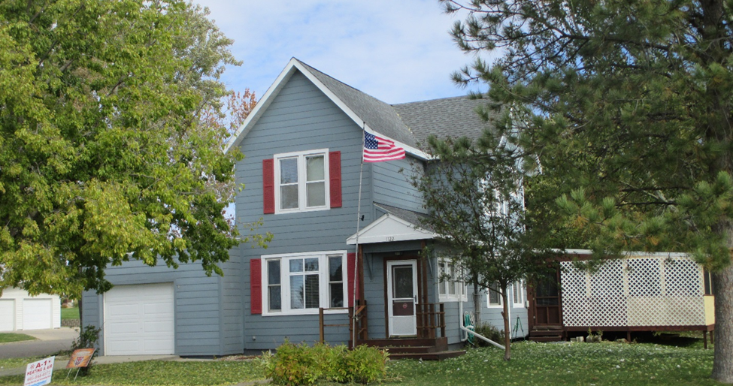
$120,000.00
BEZENEK-HANSON
1122 10TH AVE WEST, MOBRIDGE
MOBRIDGE NWTS CO’S 3RD ADDN LOT 14 BLOCK 26
RECORD #6114

LOT SIZE 68’ X 120’ GROUND FLOOR 1311 SQ FT
SINGLE FAMILY 2 STORY TOTAL AREA 2150 SQ FT
AVERAGE QUALITY & CONDITION 2 BEDROOMS ABOVE
BUILT IN 1900 1 FULL BATH, ¾ BATH, ½ BATH
2008; EGRESS WINDOW, 3 WINDOWS MAIN BASEMENT 798 SQ FT
2010; REPLACE FLOORING LIVING ROOM FINISHED FAMILY ROOM IN BSMT.
RE-SIDED HOUSE IN 2004 ATTACHED GARAGE 384 SQ FT
SOLD ON 6/29/18 FOR $120,000 WOOD DECK 478 SQ FT
ASSESSED IN 2018 $83,500
ASSESSED IN 2012 AT $47,515 RECORD #6114

