$103,000.00
SCHAEFER-ANDERSON
614 11TH ST WEST, MOBRIDGE
MOBRIDGE NWTS 2ND ADDN LOT 9 & S 6’ OF LOT 10 BLOCK 19
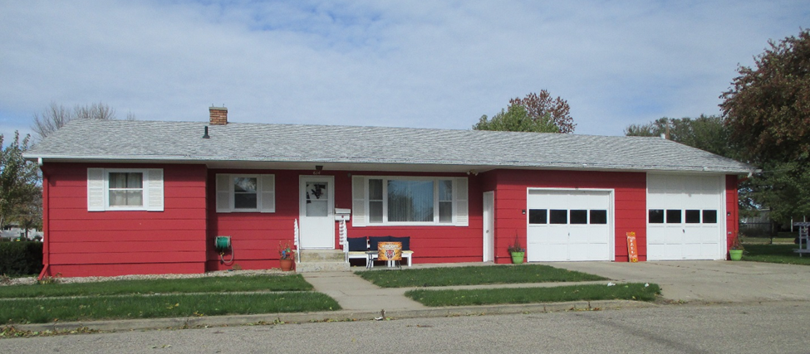
RECORD # 6049

LOT SIZE 52’ X 140’ LIVING AREA 1066 SQ FT
SINGLE FAMILY ONE STORY 3 BEDROOMS ABOVE 1 BELOW
AVERAGE QUALITY & CONDITION 1 FULL BATH, ¾ BATH, ½ BATH
BUILT IN 1965 BASEMENT 1066 SQ FT
2014; ROOF GOOD, SIDING GOOD 533 FINISHED REC. IN BSMT.
CENTRAL AIR, NATURAL GAS, WINDOWS FAIR
SOLD ON 8/2/18 FOR $103,000 ROOFED PORCH 104 SQ FT
ASSESSED IN 2018 AT $92,980 ATTACHED GARAGE 810 SQ FT
SOLD IN 2015 FOR $96,000
ASSESSED IN 2014 AT $82,945
ASSESSED IN 2012 AT $69,545 RECORD # 6049

