$17,000.00
GOURNEAU-MARTIN
712 2nd AVE EAST, MOBRIDGE
MOBRIDGE GRAND CROSSING ADDN LOT 16F BLOCK 61
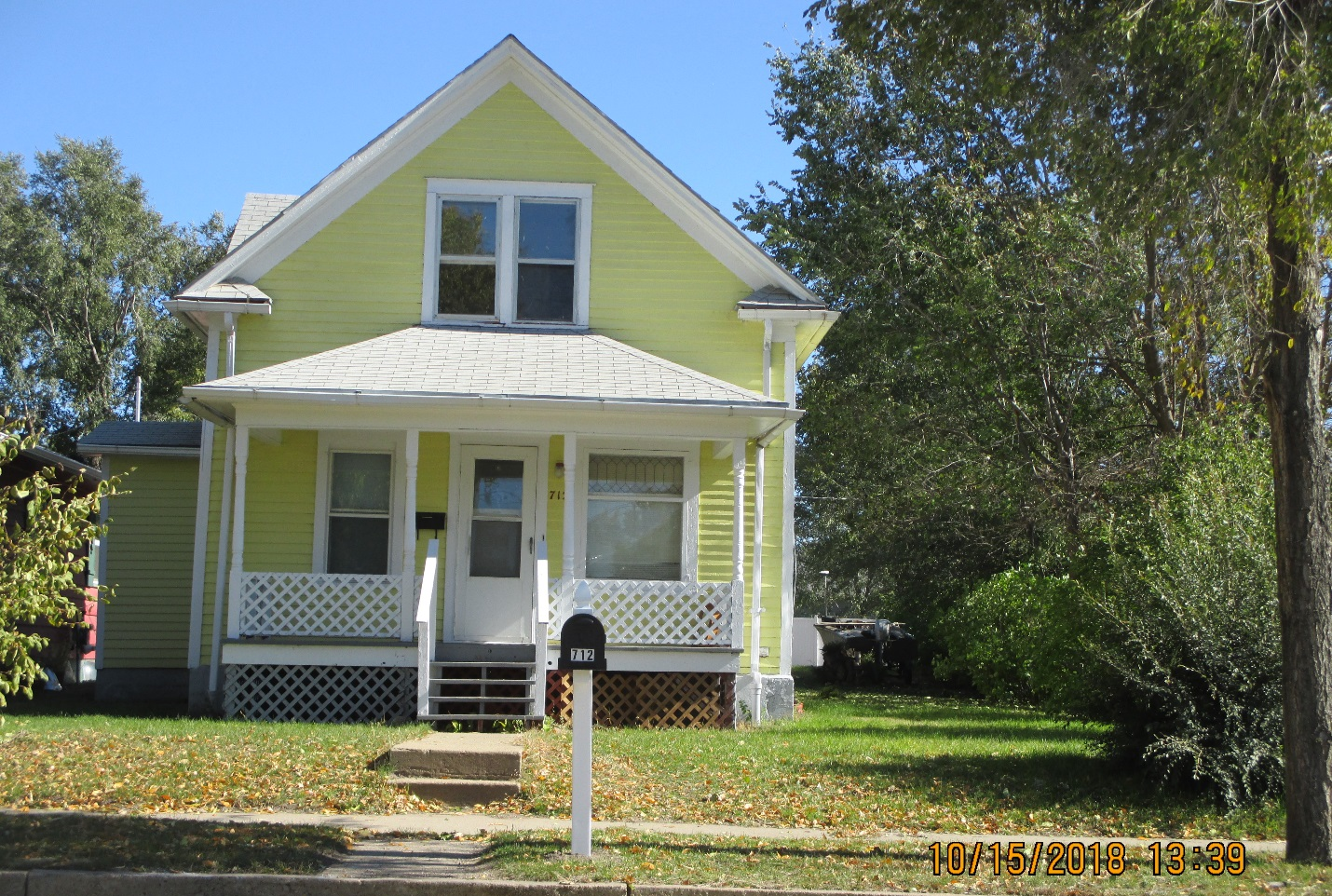
#5510

LOT SIZE 40’ X 140’ GROUND FLOOR 520 SQ FT
SINGLE FAMILY TOTAL LIVING 780 SQ FT
1 ½ STORY 3 BEDROOMS, 1 ½ BATH
AVERAG QUALITY & CONDITION DETACHED GARAGE 192 SQ FT
BUILT IN 1910
2014; CASEMENT WINDOWS POOR
LAP SIDING POOR, FOUNDATION FAIR RECORD #5510
SOLD ON 7/13/18 FOR $17,000
ASSESSED IN 2018 AT $15,430, 2012 $21,775

