$110,000.00
SHILLINGSTAD-OSTER
519 7TH AVE EAST, MOBRIDGE
MOBRIDGE FAIRVIEW ADDN LOTS 14 & 15 BLOCK 26
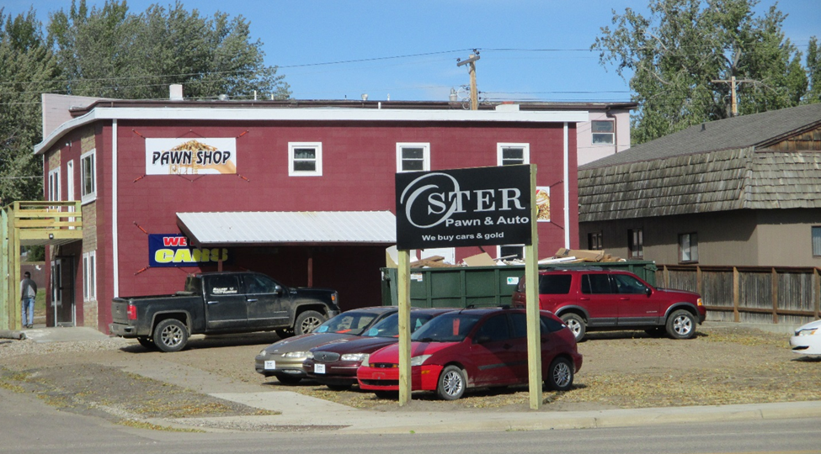
RECORD #5152

LOT SIZE 50’ X 140’ TOTAL AREA 3600 SQ FT
COMMERCIAL PAWN/AUTO 2 STORY GROUND FLOOR 1800 SQ FT
FAIR CONDITION & QUALITY
BUILT IN 1960+ -
2007; 10’ X 20’ SUNSHADE $900
2007; MOVE INTERIOR WALL $1000
2010 CLOSE 2 SIDES & WINDOWS $1500
2011; REMODEL $10,000
SOLD ON 9/1/18 FOR $110,000
ASSESSED IN 2018 AT $55,735
SOLD IN 2008 FOR $127,000
ASSESSED IN $42,775 RECORD #5152

