$80,000.00
DROOG-STAINBROOK
STR 18-124-79
LOT 3B & W 97.66’ OF LOT 4B 4TH SUBD OF GOVT LOT 2 IN NW4 18-124-79
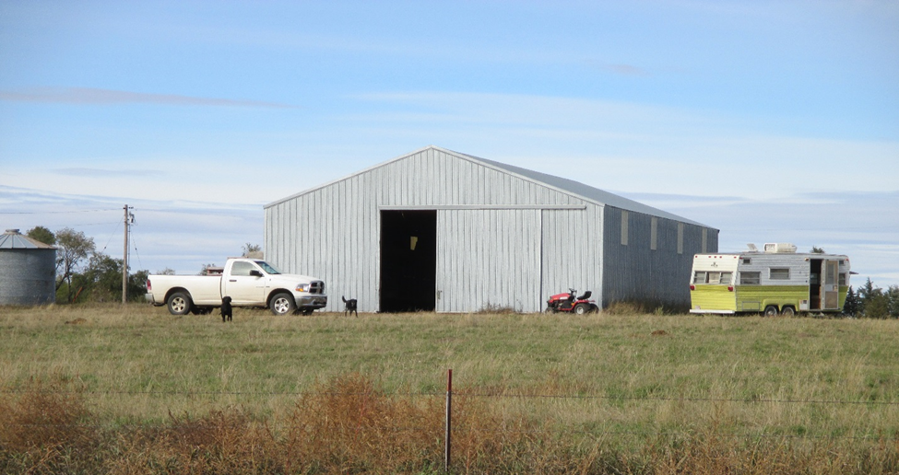
RECORD #3490

LOT SIZE 4.96 ACRES
40’ X 64’ METAL EQUIPMENT STORAGE BUILDING
BUILT IN 1993 + -
OLD GRAIN BIN 10’ RADIUS
SOLD ON 10/01/18 FOR $80,000
ASSESSED IN 2018 AT $28,590
ASSESSED IN 2012 AT $27,530 RECORD #3490

