$290,000.00
SCHELL-BODEN
2910 10TH AVE WEST, MOBRIDGE
LOTS 2A, 3A, 4A & 5A, 1ST SUBD OF GOVT LOT 2 IN NW4 18-124-79
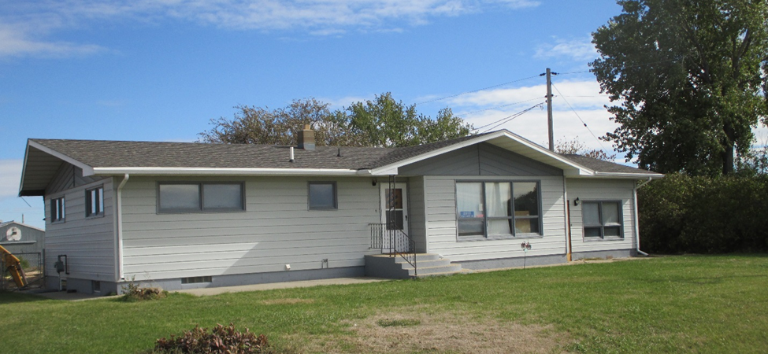
RECORD #3486

LOT SIZE 4 ACRES GROUND FLOOR 2036 SQ FT
ONE STORY SINGLE FAMILY 3 BEDROOMS 2 BATHS
AVERAGE QUALITY & CONDITION BASEMENT 1286 SQ FT
BUILT IN 1965 FINISHED LIVING 1200 SQ FT
2015; NATURAL GAS, CENTRAL AIR WOOD DECK 252 SQ FT
EGRESS NORTH, METAL SIDING 3 SEASON COVERED DECK
WOOD/METAL WINDOWS POOR 390 SQ FT ADDITION
SLIDING GLASS DOOR 1200 SQ FT STORAGE/GARAGE
LEAN TO TYPE 3 SEASON PORCH 1440 SQ FT BUILDING/BARN
SOLD ON 7/2/18 FOR $290,000
ASSESSED IN 2018 AT $255,780
SOLD IN 2017 FOR $260,000 (ESTATE AUCTION)
SOLD IN 2001 FOR $145,000
ASSESSED IN 2017 AT $190,740
ASSESSES IN 2012 AT $113,780 RECORD #3486

