$240,000.00
ULMER-RATH
718 20TH ST EAST, MOBRIDGE
TRACT 1 NEUMEYER’S ADDN IN SW4SW4 17-124-79
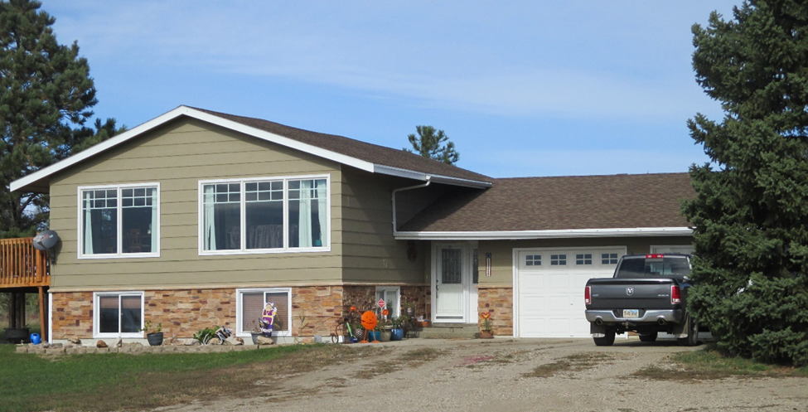
RECORD #3468

LOT SIZE 8.14 ACRES GROUND FLOOR 1230 SQ FT
SINGLE FAMILY BI-LEVEL 2 BEDROOMS ABOVE 2 BELOW
AVERAGE QUALITY & CONDITION 2 FULL BATHS 8 FIXTURES
BUILT IN 1980 BASEMENT 1092 SQ FT
2015; ROOF GOOD, WINDOWS FAIR 1000 SQ FT FINISHED LIVING BSMT
MASONITE SIDING SOME POOR SOME NEW WOOD DECK 286 SQ FT
NEW WINDOWS IN 3 SEASON PORCH 300 SQ FT OPEN SLAB PORCH
VINYL WINDOWS FAIR, CENTRAL AIR ATTACHED GARAGE 624 SQ FT
2008; 16X27 ADDN BATHROOM & WORK SPACE
SOLD ON 9/26/18 FOR $240,000 DETACHED GARAGE 308 SQ FT
ASSESSED IN 2018 AT $172,000
ASSESSED IN 2012 $127,000 RECORD #3468

