$19,000.00
ESTES-SANDERSON
308 EAST THEODORE, MOBRIDGE
SELBY ORIGINAL LOTS 5 & 6 BLOCK 1
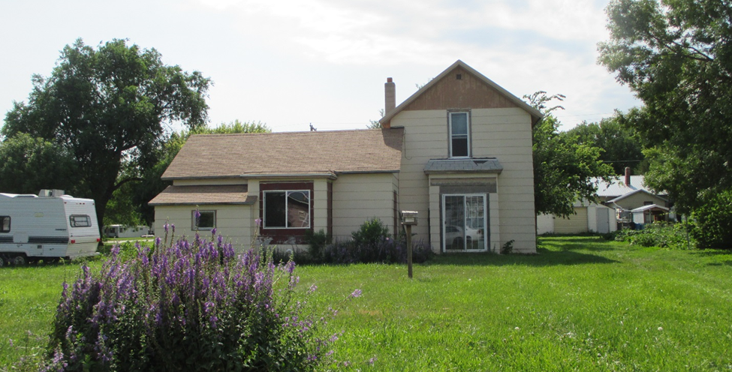
RECORD #7920

LOT SIZE 100’ X 140’ GROUND FLOOR 1216 SQ FT
SINGLE FAMILY TOTAL AREA 1424 SQ FT
1 ½ STORY 4 BEDROOMS 1 ½ BATHS
WORN CONDITION AND QUALITY SOLID WALL PORCH 50 SQ FT
BUILT IN 1920 + - OPEN SLAB PORCH 580 SQ FT
2015; ROOF SHINGLES GOOD, PART METAL BASEMENT 1216 SQ FT
SOLD ON 4/6/18 FOR $19,000.00
ASSESSED IN 2018 AT $11,745
ASSESSED IN 2012 AT $14,205 RECORD #7920

