$150,000.00
EPPERLY-TUMBLESON
302 13TH ST WEST
MOBRIDGE THOMPSON’S OUTLOTS, LOT 22
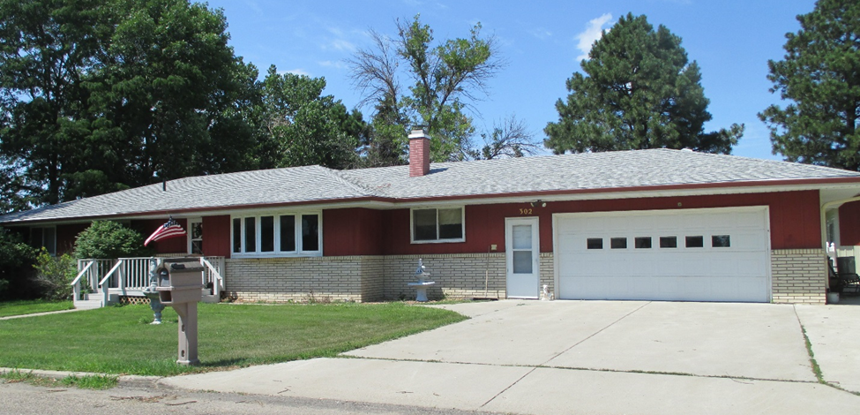
RECORD #6508

LOT SIZE 165’ X 264’ GROUND FLOOR 1356 SQ FT
SINGLE FAMILY ONE STORY 4 BEDROOMS
AVERAGE QUALITY & CONDITION 2 FULL BATHS 2 HALF BATHS
BUILT IN 1968 BASEMENT 1356 SQ FT
2015; ROOF GOOD, METAL SIDING 1100 SQ FT FIN LIVING IN BSMT
CENTRAL AIR, NATURAL GAS DETACHED GARAGE 900 SQ FT
SOLD ON 4/25/18 FOR $150,000 ATTACHED GARAGE 576 SQ FT
ASSESSED IN 2018 AT $166,340 WOOD DECK 150 SQ FT
ASSESSED IN 2012 AT $94,100 192 SQ FT SHED

