$92,000.00
WHEELER-LUCEK
MAIN ST. MOBRIDGE
MOBRIDGE ORIGINAL PLAT LOT 1 BLOCK 11
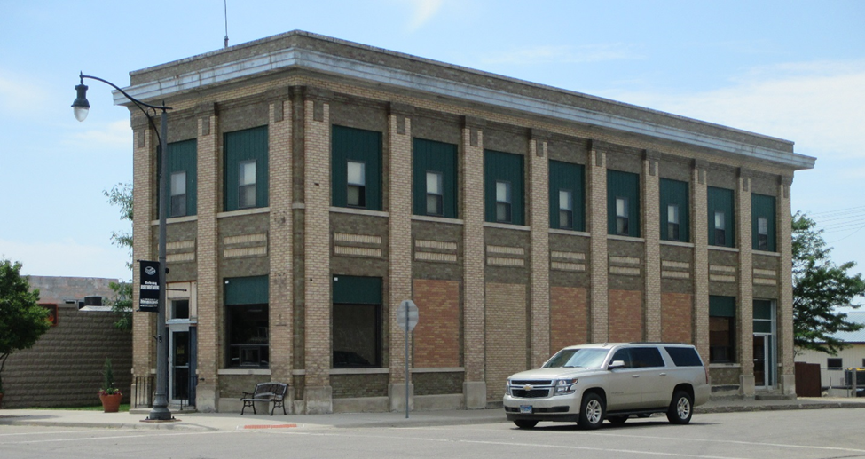
RECORD #6332

LOT SIZE 25’ X 140’
2 STORY
100% COMMERCIAL
AVERAGE QUALITY & CONDITION
GROUND FLOOR 2,125 SQ FT
SECOND FLOOR 2,125 SQ FT
UNFINISHED BASEMENT 4,250 SQ FT
SOLD ON 3/9/18 FOR $92,000
ASSESSED IN 2018 AT $75,210
SOLD IN 2005 FOR $45,000
ASSESSED IN 2012 AT $34,255 RECORD #6332

