$25,000.00
DUTT-BWRIE INVESTMENTS LLC
MAIN ST. MOBRIDGE
MOBRIDGE ORIGINAL PLAT LOTS 7,8 & 9 BLOCK 10
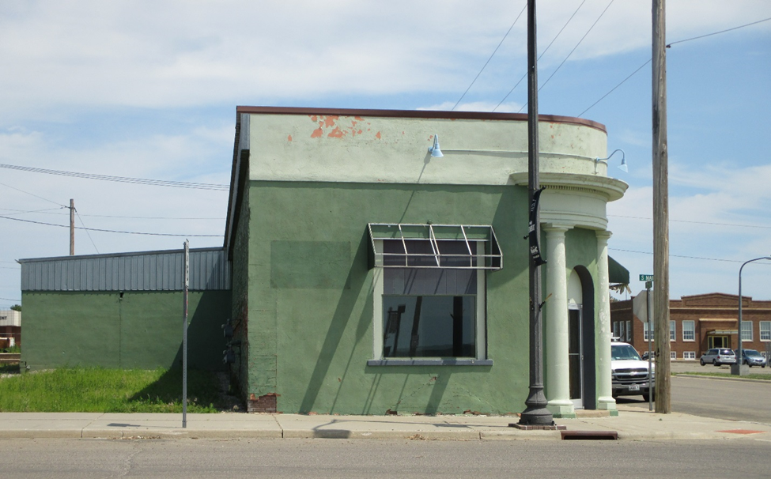
RECORD #6323

LOT SIZE 75’ X 140’ 5100 SQ FT
WAREHOUSE SPACE HEATER
LOW QUALITY
AVERAGE CONDITION
BUILT IN 1925
SOLD ON 3/22/18 FOR $25,000
ASSESSED IN 2018 AT $38,430
SOLD IN 2010 FOR $30,000
ASSESSED IN 2012 AT $33,010 #6323
NO BASEMENT

