$136,000.00
PIATT-ECKROTH
1004 11TH ST W. MOBRIDGE
MOBRIDGE NETS CO’S 3RD ADDN LOTS 6 & 7 BLOCK 26
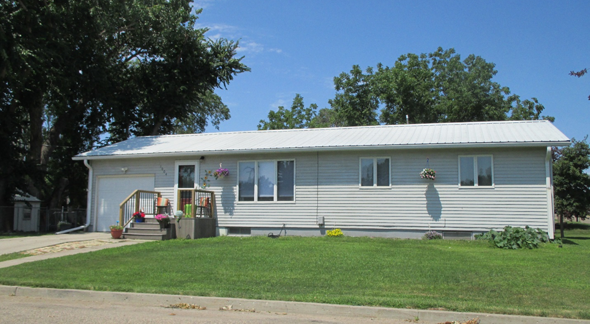
RECORD # 6112

LOTS SIZE 100’ X 120’ GROUND FLOOR 984 SQ FT
ONE STORY SINGLE FAMILY 3 BEDROOMS 1 ½ BATHS
AVERAGE QUALITY & CONDITION BASEMENT 984 SQ FT
BUILT IN 1963 450 SQ FT FINISHED REC.
2014; METAL ROOF, ALUMINUM SIDING ATTACHED GARAGE 312 SQ FT
WINDOWS GOOD, SOME NEWER SPRINKLER SYSTEM
CENRAL AIR WOOD DECK 205 SQ FT
SOLD ON 4/5/18 FOR $136,000 SMALL TOOL SHED
ASSESSED IN 2018 AT $108,330
SOLD IN 2014 FOR $77,500
ASSESSED IN 2012 $41,440 RECORD #6112

