$12,000.00
HOWELL-DEACON
414 3RD AVE EAST, MOBRIDGE
MOBRIDGE-MILW LAND CO’S 2ND ADDN LOT 10 BLOCK 27
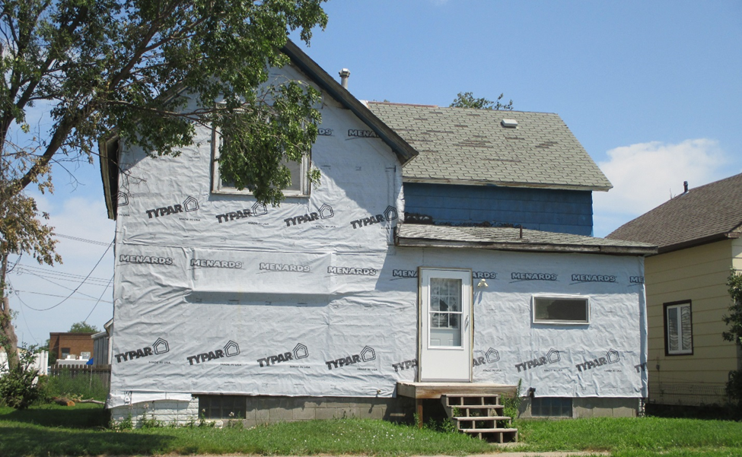
RECORD #5864

LOT SIZE 50’ X 140’ GROUND FLOOR 896 SQ FT
SINGLE FAMILY 1 ½ STORY TOTAL LIVING AREA 1232 SQ FT
AVERAGE QUALITY & CONDITION 4 BEDROOMS
BUILT IN 1918 2 FULL BATHS ONE ½ BATH
2014; BEING WORKED ON, NEW WINDOWS WOOD DECK 98 SQ FT
WOOD SHED VERY POOR, NATURAL GAS BASEMENT 672 SQ FT
SOLD ON 5/7/18 FOR $12,000 DETACHED GARAGE 736 SQ FT
ASSESSED IN 2018 AT $11,300
ASSESSED IN 2012 AT $12,405 RECORD #5864

