$59,500.00
PEACOCK-SCHAEFBAUER
1101 1ST AVE WEST, MOBRIDGE
MAIN PARK LOT 10 BLOCK 24
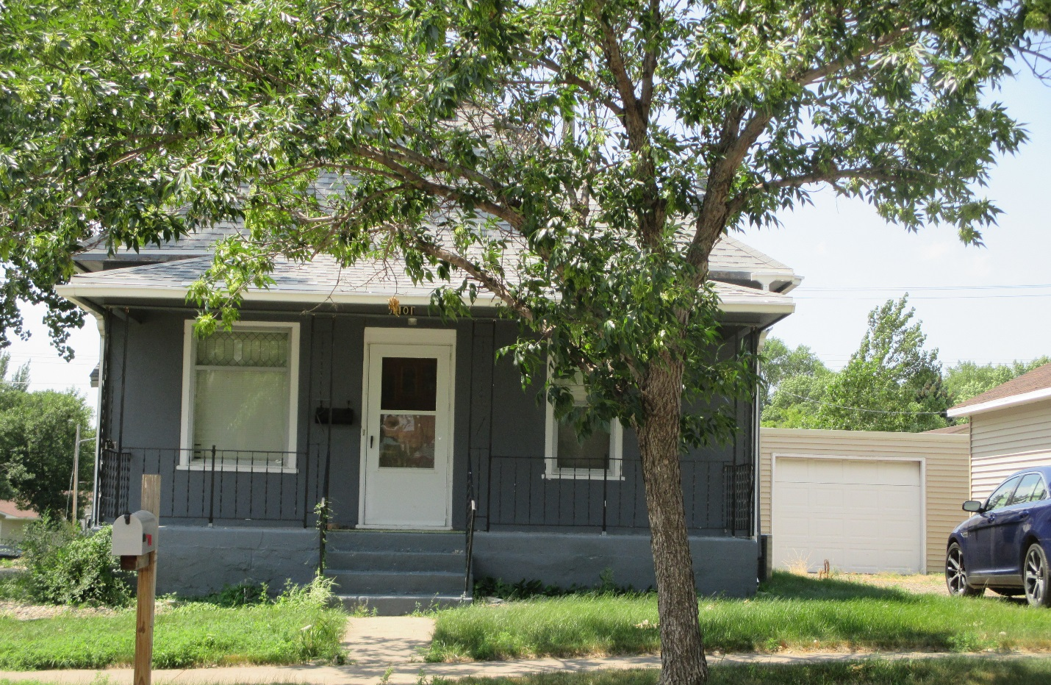
RECORD #5727

LOT SIZE 37.5’X142’ GROUND FLOOR 1020 SQ FT
ONE STORY SINGLE FAMILY 2 BEDROOMS ¾ BATHROOM
AVERAGE QUALITY & CONDITION BASEMENT 672 SQ FT FINISHED
BUILT IN 1920 DETACHED GARAGE 432 SQ FT
NATURAL GAS WINDOW AIR STUCCO WALLS
2008 18’X24’ DETACHED GARAGE $7,000 COVERED CONCRETE PORCH
SOLD ON 10/20/17 FOR $59,500
ASSESSED IN 2017 AT $50,450
ASSESSED IN 2012 AT $22,530 RECORD #5727

