$47,000.00
HOWELL-HELM
EAST GRAND CROSSING, MOBRIDGE
MOBRIDGE FAIRVIEW ADDN LOTS 14 & 15 BLOCK 27
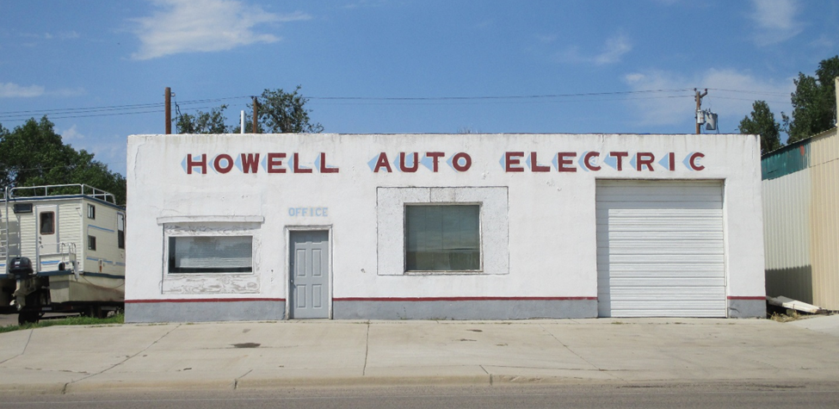
RECORD #5162

LOTS SIZE 50’ X 140’
COMMERCIAL
SERVICE & REPAIR GARAGE
BUILT IN 1950+ -
SINGLE STORY
WORN CONDITION
CONCRETE BLOCK STUCCO
SOLD ON 1/25/18 FOR $47,000 RECORD #5162
ASSESSED IN 2018 AT $45,245
ASSESSED IN 2012 AT $39,346
TOTAL AREA 5252 SQ FT

