$40,000.00
LITCHEWSKI- B&L ENTERPRISES LLC
215 5TH AVE EAST, MOBRIDGE
MOBRIDGE EKLO’S 1ST ADDN LOT 3 BLOCK 3
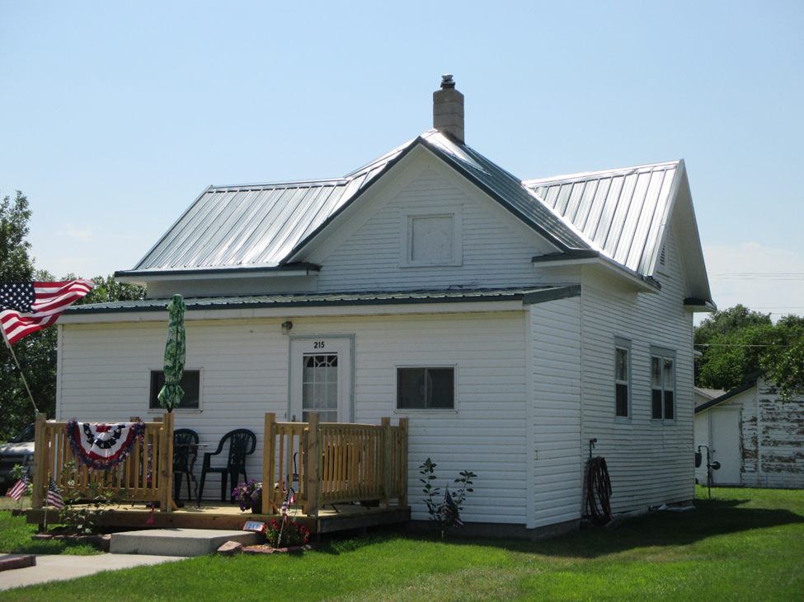
RECORD #4906

LOT SIZE 50’ X 140’ TOTAL LIVING AREA 542 SQ FT
SINGLE FAMILY ONE STORY 2 BEDROOMS 1 BATH
WORN QUALITY & CONDITION DETACHED GARAGE 480 SQ FT
BUILT IN 1915 WOOD DECK 120 SQ FT
CENTRAL AIR NATURAL GAS SHED 136 SQ FT
SOLD ON 4/7/18 FOR $40,000 STORAGE BLDG. 408 SQ FT
ASSESSED IN 2018 AT $22,800
ASSESSED IN 2012 AT $7,555 RECORD #4906

