$112,500.00
ADNEY,MOLER,FUHRMAN-SOPHER
1305 PARK LANE, MOBRIDGE
MOBRIDGE BEL AIRE 2ND 1ST SUB LOT 5 BLOCK 5
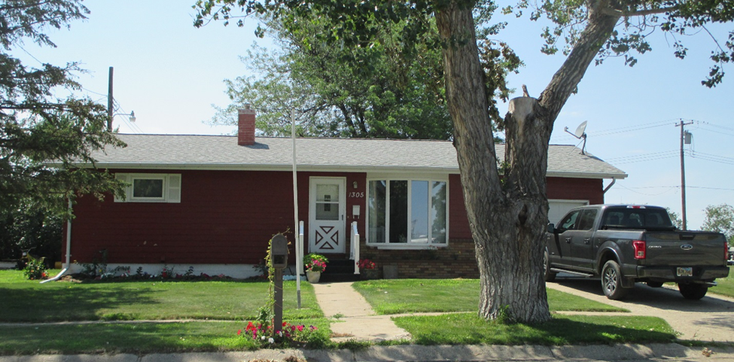
RECORD #4729

LOT SIZE 80’ X 125’ GROUND FLOOR 888 SQ FT
SINGLE FAMILY ONE STORY BASEMENT 888 SQ FT
AVERAGE QUALITY & CONDITION BSMT. 800 FINISHED REC.
BUILT IN 1962 2 BEDROOMS ABOVE 2 BELOW
2014; CENTRAL AIR, NATURAL GAS 1 FULL BATH, ONE ¾ BATH
METAL WINDOWS FAIR ATTACHED GARAGE 264 SQ FT
SOLD ON 2/27/18 FOR $112,500 DETACHED GARAGE SQ FT
ASSESSED IN 2018 AT $114,150 WOOD DECK 168 SQ FT
ASSESSED IN 2012 AT $53,630 COVERED PATIO 252 SQ FT
CARPORT, 12’X8’ WOOD SHED

RECORD #4729

