$94,000.00
VELDHUISEN-KAISER
1215 3RD AVE WEST, MOBRIDGE
MOBRIDGE BEL AIRE 1ST ADDN LOT 5 BLOCK 1
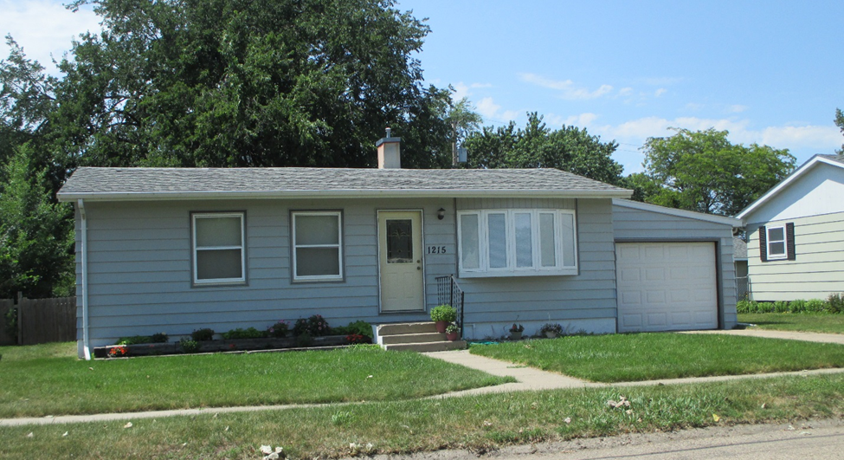
RECORD #4700

LOT SIZE 60’ X 130’ GROUND FLOOR 864 SQ FT
SINGLE FAMILY 1 STORY 2 BEDROOMS 1 BATH
AVERAGE QUALITY & CONDITION BASEMENT 864 SQ FT FINISHED
BUILT IN 1963 ATTACHED GARAGE 528 SQ FT
2014; ROOF FAIR, STEEL SIDING GARAGE ADDN 240 SQ FT
CENTRAL AIR, WINDOWS GOOD 16’ X 12’ UTILITY SHED
NO ALLEY ACCESS, BOW WINDOW EAST 6’ X 57’ WOOD FENCE
SOLD ON 4/6/18 FOR $94,000
ASSESSED IN 2018 AT $84,530 RECORD #4700
SOLD IN 2013 FOR $85,000
ASSESSED IN 2012 AT $60,275

