$67,000.00
MOSER-JOHNSON
4501 3RD AVE. SELBY
SELBY ORIGINAL LOT 7 & S ½ LOT 8 BLOCK 2
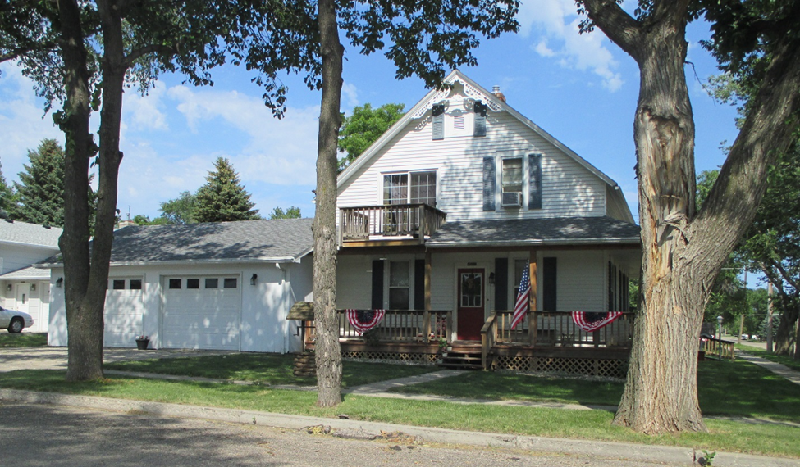
RECORD #4411

LOT SIZE 75’ X 140’ GROUND FLOOR 780 SQ FT
SINGLE FAMILY 1 ½ STORY TOTAL LIVING AREA 1326 SQ FT
AVERAGE QUALITY & CONDITION ONE FULL BATH, ONE ¾ BATH
BUILT IN 1914 ONE ½ BATH, 3 BEDROOMS
2015; ROOF GOOD BASEMENT 438 SQ FT FINISHED
DETACHED SHED ROOF GOOD 2 STALL ATTACHED GARAGE
NATURAL GAS CENTRAL AIR SHED 468 SQ FT
WRAP AROUND DECK; WEST,SOUTH,EAST CARPORT 416 SQ FT
SOLD ON 3/23/18 FOR $67,000 WOOD DECK 537 SQ FT
ASSESSED IN 2018 AT $86,080 WRAP AROUND DECK 600 SQ FT
SOLD IN 2006 FOR $74,000
ASSESSED IN 2012 AT $65,050 RECORD #4411

