$110,000.00
MORROW-RUSSEL
4109 6TH AVE
SELBY MILW LAND CO’S 2ND ADDN S ½ LOT 2 & ALL LOT 3 BLOCK 27
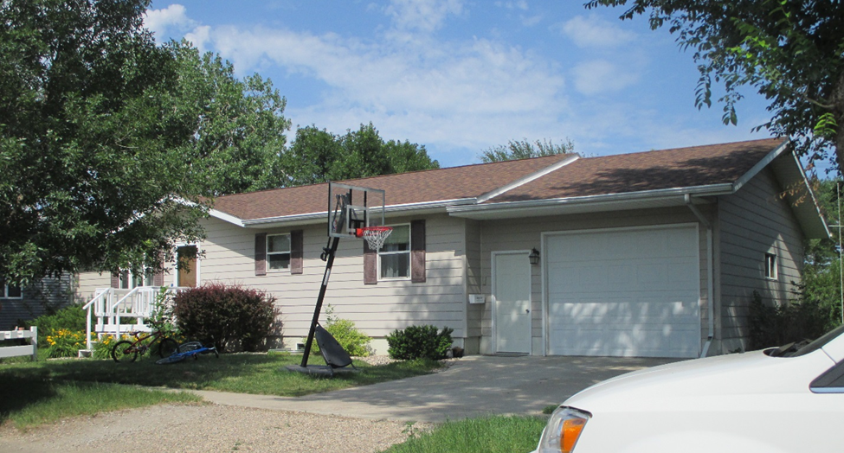
RECORS #4359

LOT SIZE 75’ X 140’ GROUND FLOOR 1232 SQ FT
SINGLE FAMILY ONE STORY 2 BEDROOMS 1FULL BATH
AVERAGE QUALITY & CONDITION ONE ½ BATH
BUILT IN 2001 AT KEN’S LUMBER BASEMENT 1232 SQ FT
2015; CENTRAL AIR NATURAL GAS GARAGE 400 SQ FT
2002; NEW GARAGE
SOLD ON 5/8/18 FOR $110,000
ASSESSED IN 2018 AT $138,990
SOLD IN 2002 FOR $75,000
ASSESSED IN 2012 AT $76,110 RECORD #4359

