$15,000.00
GEDITZ-MEES
AKASKA
AKASKA S 39.23’OF LOT 16 OF PLAT OF LOTS 15, 16, 17 & 18 OF OUTLOT 2 & E2 LOT 1 BLK 2 & ALL LOT 7 BLK 1 VACATING LOT2 OF OUTLOT 2
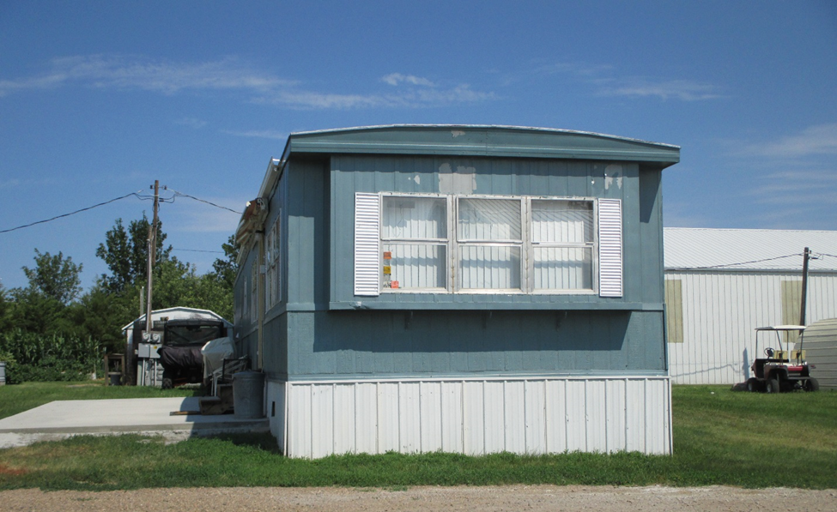
RECORD #3816

LOT SIZE 39’ X 95’
MANUFACTURED HOME
BUILT IN 1972
14’ x 70’ GEER
MH SOLD IN 2016 FOR $4,000
LOT SOLD IN 2016 FOR $8,000
ASSESSED IN 2018 AT $8,880
ASSESSED IN 2016 AT $5,565 RECORD #3816

