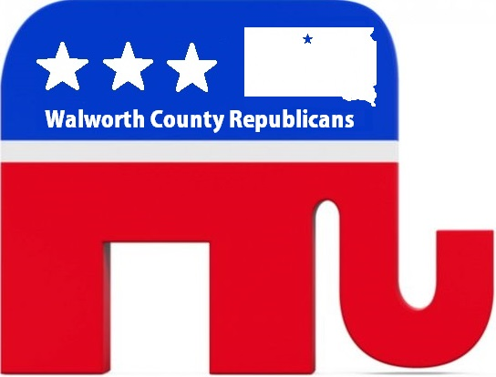
AGENDA
Walworth County Republican Party
Date | time July 23, 2018 | 5:30 pm | Meeting called by Republican Party

Board members
Spencer Gosch | Eric Stroeder | Rebecca Krein | Jim Houck | Jamie Hare | Kevin Holgard | Nyla Moak | Scott Schilling | Joshua Boll | Marion Schlomer | Eric Schley | David Siemon | Vivian Witlock | David Witlock | Trent Thorstenson | Ashley Gosch | Rebecca Witlock|
Time | Item
5:30 pm | Welcome
5:33 pm | Motions for Temporary Secretary
5:35 pm | Open Nominations for the Register of Deeds Republican Candidate
5:38 pm | Cease nominations and allow for 3 minutes nominee Speeches
5:55 pm | Close the floor for speeches, open it up for voting
5:57 pm | Open nominations and vote for the Republican Executive Committee to include:  - Chair  - Vice Chair  - Secretary/Treasure  - Committee Man  - Committee Woman
6:00 pm | Committee Discussion
6:05 pm | Adjournment

