$70,000.00
PIATT CONSTRUCTION-LOCKNER
724 4TH AVE WEST, MOBRIDGE
MOBRIDGE GRAND CROSSING ADDN LOTS 11 & 12 BLOCK 55
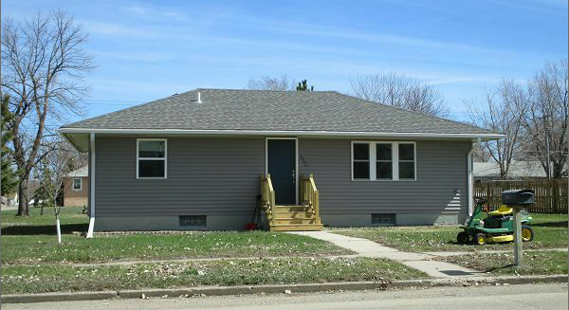
RECORD #5419

LOT SIZE 100’ X 140’ GROUND FLOOR 720 SQ FT
SINGLE FAMILY 3 BEDROOMS
ONE STORY 1 ¼ BATHS 6 FIXTURES
BUILT IN 1959 FINISHED BASEMENT 720 SQ FT
HEATED AND COOLED DETACHED GARAGE 14’X20’
2016 NEW WINDOWS ,SIDING
SHINGLES, WOOD DECK
SOLD ON 10/28/16 FOR $70,000
ASSESSED IN 2016 AT $43,915 RECORD #5419
ASSESSED IN 2012 AT $37,595

SOLD IN 2015 FOR $43,500; IN 2007 FOR $39,000

