$560,000.00
FLIEHS-WEBSTER
2019 SCHIRBER DR. MOBRIDGE
SCHIRBER’S 2ND ADDITION LOT 1 STR 13-124-80
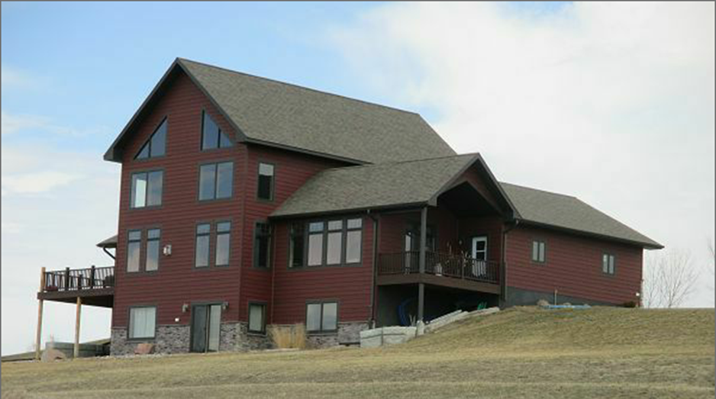
RECORD #7902

LOT SIZE 1.91 ACRES 2390 SQ FT
SINGLE FAMILY 2 STORY FRAME 3 BEDROOMS 3 ½ BATHS
NORMAL CONDITION & QUALITY LOFT WITH WALKOUT BSMT.
ELECTRIC HEAT CENTRAL AIR 2 STALL ATTACHED GARAGE
BUILT IN 2013 WOOD DECK 420 SQ FT
CHERRY WOOD FLOORS & CABINETS FINISHED BASEMENT 1000 SQ FT
GRANITE COUNTER TOPS
HEATED BASEMENT, BATHROOM FLOORS
SOLD ON 7/28/17 FOR $560,000
ASSESSED IN 2018 AT $426,740
ASSESSED IN 2014 AT $307,235

