$30,000.00
BELFIELD-HAEFNER
012 BRISCO ST. GLENHAM
GLENHAM ORIGINAL LOTS 8,9,10 BLOVCK 6
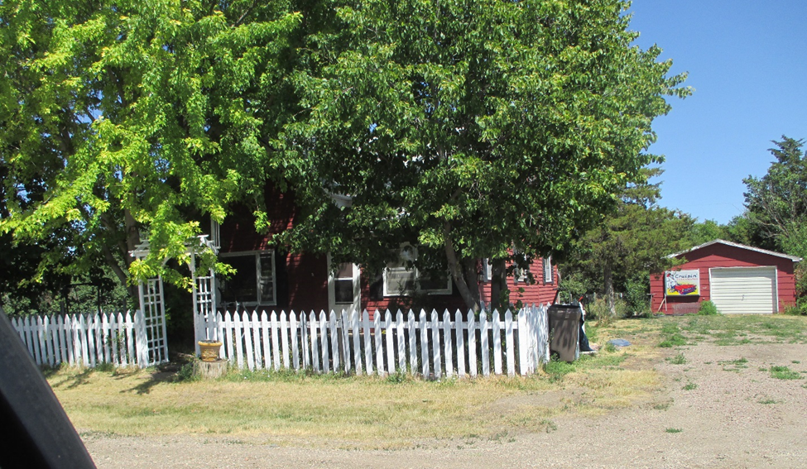
RECORD #7663

ON 3 LOTS GROUND FLOOR 735 SQ FT
SINGLE FAMILY 1 ½ STORY TOTAL LIVING 1017 SQ FT
AVERAGE QUALITY AND CONDITION DETACHED GARAGE 480 SQ FT
BUILT IN 1900 3 BEDROOMS
SOLD ON 6/2/17 FOR $30,000 1 BATH
ASSESSED IN 2017 AT $18,750
SOLD IN 2006 FOR $22,000
ASSESSED IN 2012 AT $16,305 RECORD #7663

