$55,000.00
HOUCK-BADDING
310 ANNA ST. AKASKA
AKASKA GOETZ ADDN LOT 10 BLOCK 3
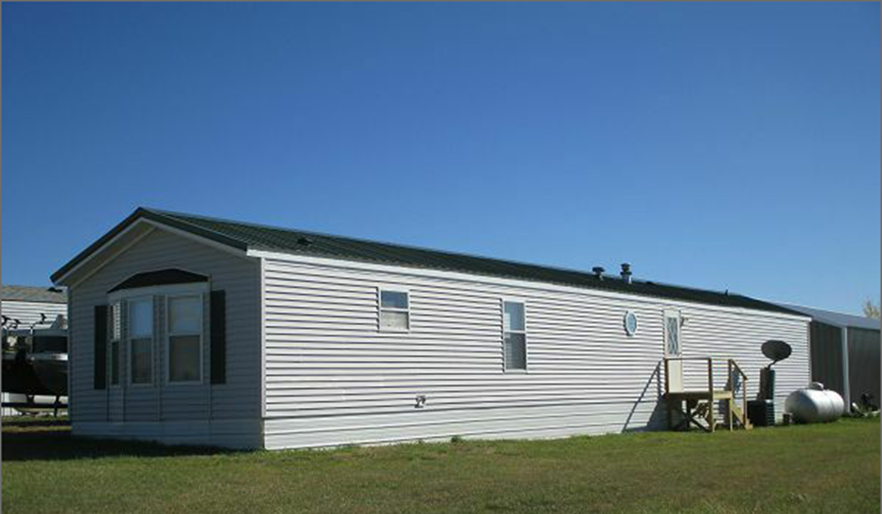
RECORD #7589

LOT SIZE 50’ X 100’ TOTAL LIVING AREA 1,216 SQ FT
MANUFACTURED HOME METAL ROOF VINYL SIDING
BUILT IN 1998 CENTRAL AIR
WARMED AND COOLED
SOLD ON 7/10/17 FOR $55,000
ASSESSED IN 2017 AT $34,745 RECORD #7589
ASSESSED IN 2012 AT $33,550

