$130,000.00
GEARY-PETERSON
818 4TH AVE WEST, MOBRIDGE
MOBRIDGE NWTS CO’S 1ST ADDN LOT 3A REPLAT OF LOTS 11-14 BLOCK 12
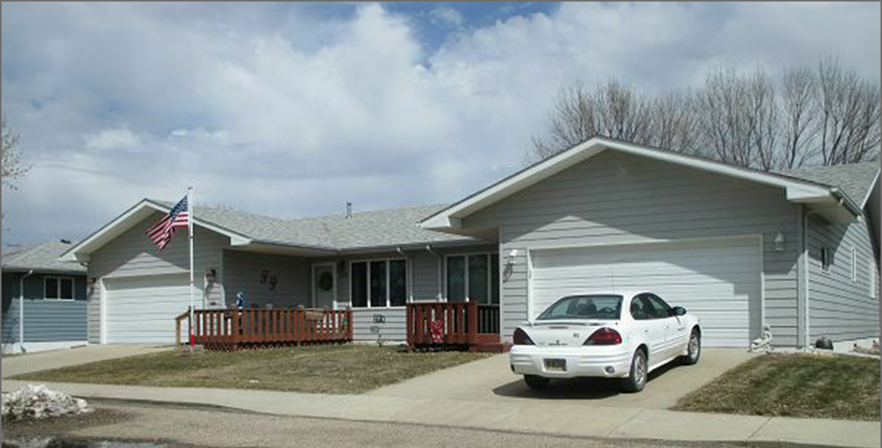
RECORD #7572

LOT SIZE 44.2’ X 98’ GROUND FLOOR 1168 SQ FT
ONE STORY DUPLEX FINISHED BASEMENT 1168 SQ FT
SINGLE FAMILY 2 BEDROOMS ABOVE
AVERAGE QUALITY & CONDITION 2 BEDROOMS BELOW
BUILT IN 1994 2 ½ BATHS
2014; SHINGLES GOOD, WINDOWS GOOD ATTACHED GARAGE 440 SQ FT
CENTRAL AIR-NATURAL GAS WOOD DECK 208 SQ FT
SOLD ON 12/21/17 FOR $130,000
ASSESSED IN 2018 AT $111,090 RECORD #7572
ASSESSED IN 2012 AT $122,240
SOLD IN 2014 FOR $102,000, SOLD IN 2003 FOR $85,000

