$70,000.00
BANKWEST INC – MERKEL
809 6TH ST EAST, MOBRIDGE
MOBRIDGE FAIRVIEW ADDN LTS 17 & 18 BLOCK 25
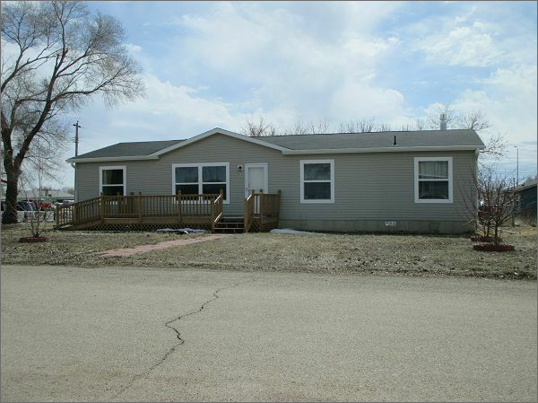
RECORD #7475

LOT SIZE 100’ X 140’ TOTAL LIVING AREA 1680 SQ FT
ONE STORY – SINGLE FAMILY 3 BEDROOMS 2 BATHS
AVERAGE QUALITY & CONDITION 8’ X 24’ WOOD DECK
2012 28’ X 60’ FRIENDSHIP MH BUILT IN 2012
NATURAL GAS – CENTRAL AIR
2014; ROOF GOOD, WOOD BURNER
VINYL SIDING/CASEMENT WINDOWS GOOD
SOLD ON 2/27/18 FOR $70,000
ASSESSED IN 2018 AT $91,390, 2013 AT $98,190

