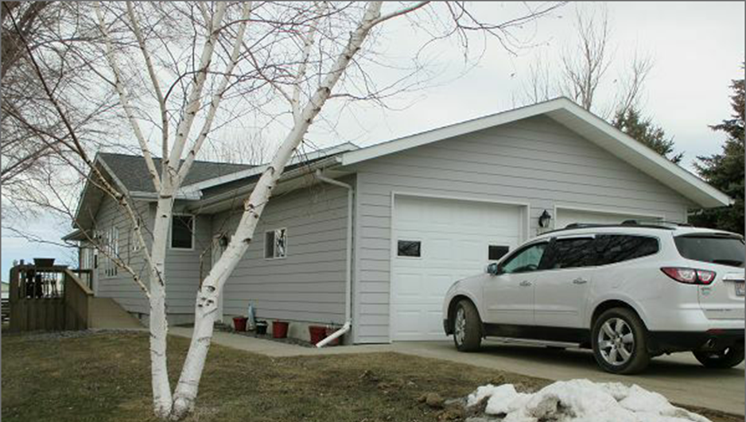
$142,500.00
BOSCHEE-GEARY
311 LYNDEE DR. SELBY
SELBY PLAINVIEW 2ND ADDN S. 75’ OF LOT 5 BLOCK 1 & N. 5’ OF LOT 4 BLOCK 7
RECORD #7376

LOT SIZE 75’ X 140’ GROUND FLOOR 1512 SQ FT
SINGLE FAMILY ONE STORY NO BASEMENT
AVERAGE QUALITY AND CONDITION 3 BEDROOMS 2 BATHS
BUILT IN 1999 24’ X 26’ ATTACHED GARAGE
CENTRAL AIR NATURAL GAS 10’ X 14’ WOOD DECK
2014; 10’ X 14’ X 10’ SHED 12’ X 8’ WOOD DECK
SOLD ON 12/19/17 FOR $142,500
ASSESSED IN 2017 AT $120,460 RECORD # 7376
SOLD IN 2012 FOR $98,000
SOLD IN 2011 FOR $85,000; 2004 FOR $77,500
ASSESSED IN 2012 AT $98,290

