$130,000.00
MERKEL-MERKEL
308 13TH ST WEST, MOBRIDGE
MOBRIDGE THOMPSON’S OUTLOTS W ½ LOT 23
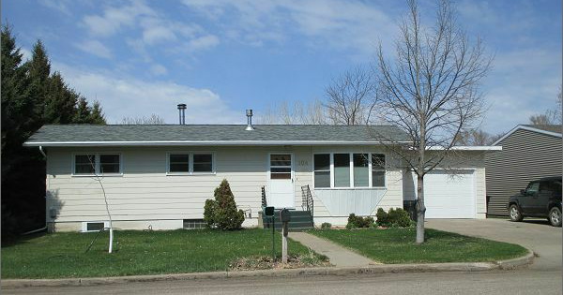
RECORD # 6511

LOT SIZE 82.5’ X 132’ GROUND FLOOR 1176 SQ FT
SINGLE FAMILY ONE STORY 2 BEDROOMS 1 BATH
AVERAGE QUALITY AND CONDITION BASEMENT 1176 SQ FT
BUILT IN 1968 IN BASEMENT 2 BEDROOMS ¾ BATH
NATURAL GAS CENTRAL AIR OFFICE IN BASEMENT
2014; MASONITE SIDING, SLAB PATIO NORTH ATTACHED GARAGE 448 SQ FT
WOOD DECK NORTH SLIDING GLASS WOOD DECK 130 SQ FT
1 EGRESS NORTH 1 EGRESS SOUTH FIREPLACE
CONCRETE 2’ AROUND FDN NORTH + WEST
SOLD ON 11/28/16 FOR $130,000
ASSESSED IN 2016 AT $110,000, IN 2012 AT $54,410 RECORD # 6511
2004 NEW SIDING AND SPRINKLER SYSTEM $10,000

