$76,000.00
STRONG HEART – PIATT
213 14TH ST EAST, MOBRIDGE
MOBRIDGE THOMPSON’S OUTLOTS N ½ OF LOT 13
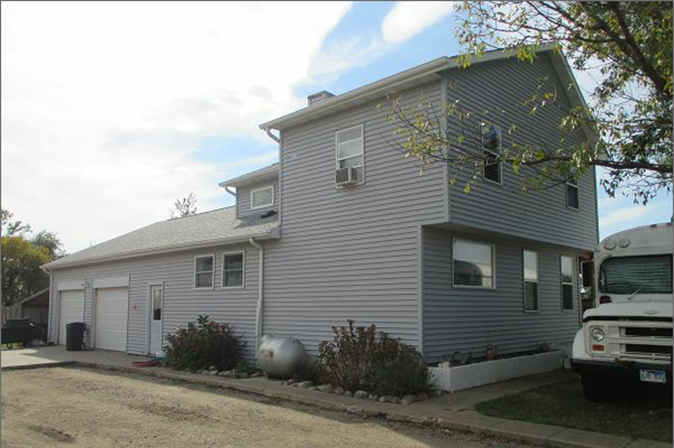
RECORD #6482
LOT SIZE 133.6’ X 132’ GROUND FLOOR 840 SQ FT
SINGLE FAMILY 2 STORY 1310 TOTAL SQ FT
AVERAGE QUALITY & CONDITION 4 BEDROOMS 1 ½ BATHS
BUILT IN 1920 BASEMENT 840 SQ FT
2007; REMODEL BATHROOM & KITHCHEN ½ FINISHED REC BSMT
2013; ADD BEDROOM ATTACHED GARAGE 576 SQ FT
2015 VINYL SIDING, METAL WINDOWS ROOFED PORCH 132 SQ FT
SOLD ON 8/11/17 FOR $76,000 2 METAL UTILITY SHEDS
ASSESSED IN 2017 AT $78,160 RECORD #6482
SOLD IN 2015 FOR $61,500 ASSESSED IN 2015 AT $22,470

